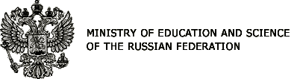 |  | 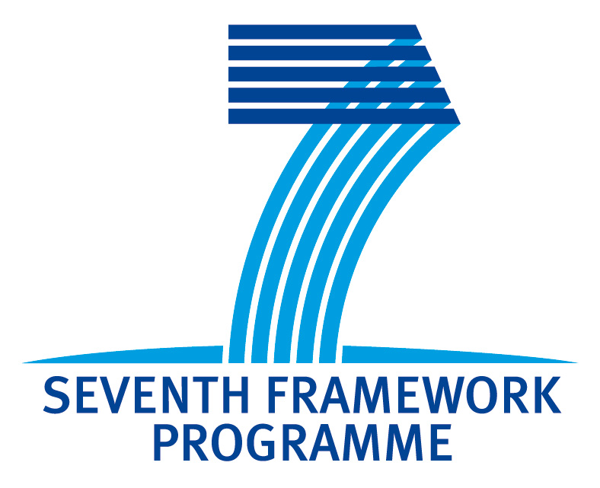
 | 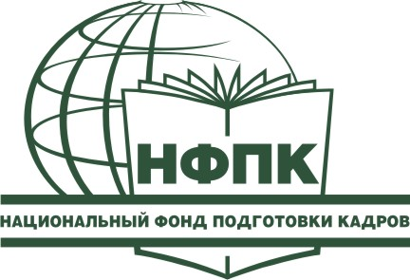 | 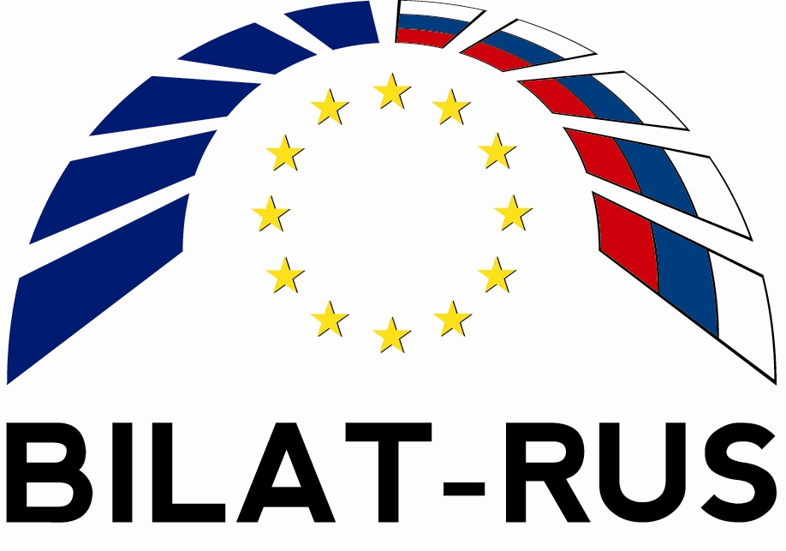
INTERNATIONAL CONFERENCE
INTERNATIONAL COOPERATION IN EDUCATION AND SCIENCE
PROGRAMME
Draft
25-26 October 2011
Pokrovkiy bulv., 11, HSE, Room Г-313
Moscow, Russia

25 OCTOBER
09:30-10:00 | Registration
WORKSHOP
RUSSIA-EU COOPERATION IN ACADEMIC MOBILITY
10:00-10:20 | Opening  Sergey Ivanets, Deputy Minister of Education and Science of the Russian Federation  Leonid Gokhberg, First Vice-rector, Director Institute for Statistical Studies and Economics of Knowledge, National Research University “Higher School of Economics”
10:20-10:50 | Trans-national Integration in Science and Education: Russian Initiatives  Igor Procenko, Director, Department for External Integration, Ministry of Education and Science of the Russian Federation
10:50-11:20 | EU-Russia Science & Technology Cooperation: State-of-the-Art and Opportunities  Manuel Hallen, Minister Counsellor Science & Technology, Delegation of the European Union to the Russian Federation
11:20-11:40 | Coffee
11:40-12:10 | Marie Curie Actions: Mobility and Training for International Research Collaboration beyond 2013  Manuel Hallen, Minister Counsellor Science & Technology, Delegation of the European Union to the Russian Federation
12:10-12:40 | Instruments to Coordinate Russia-EU Researcher Mobility: State-of-the-Art and Prospects  Anna Pikalova, Director of the Centre for International Projects, Institute for Statistical Studies and Economics of Knowledge, National Research University “Higher School of Economics”, Co-Chair of EU-Russia Working Group on Researcher Mobility
12:40-14:00 | Lunch
14:00-16:10 | EU Programmes, Instruments and Foundations: State-of-the-Art, Results, Barriers and Prospects to Cooperate with Russia  Marie Curie Actions, EURAXESS  Alexander Mazurin, Senior Researcher, Institute for Statistical Studies and Economics of Knowledge, National Research University “Higher School of Economics”, Russian National Contact Point “Mobility”  FP7 Ideas (European Research Council)  Yuriy Zaitsev, Researcher, Institute for Statistical Studies and Economics of Knowledge, National Research University “Higher School of Economics”, Russian National Contact Point “INCO”  Access by EU Researchers to Russian R&D and Innovation Programmes  Irina Kouklina, Director, Analytical Centre for International Science and Education Programmes  Erasmus Mundus, Tempus  Nicola Scaramuzzo, Education Programmes, EU-Russia Cooperation Section, Delegation of the European Union to the Russian Federation  Q&A
16:10-16:30 | Coffee
ROUND TABLE DISCUSSION
NATIONAL EU MEMBER STATES & RUSSIA INITIATIVES TO SUPPORT ACADEMIC MOBILITY
16:30-18:30 | Moderator:  Igor Morozov, Deputy Head of the Federal Agency on Commonwealth Independent States Affairs, Compatriots - Abroad Residents and International Humanitarian Co-operation (Rossotrudnichestvo)  Petr Stefanovich, Head, Humboldt – Foundation Office, Moscow  Michel Tararine, Head, Moscow Office of National Research Centre, CNRS France  Alexander Sharov, Head, Directorate for International Relations, Russian Foundation for Basic Research  Mikhail Ugrumov, Member of the Russian Academy of Sciences, Counsellor of Vice-President RAS on International Scientific Activities

26 OCTOBER
09:30-10:00 | Registration
10:00-10:10 | Opening  Maria Yudkevich, Vice-rector, National Research University “Higher School of Economics”
10:10-10:30 | Development of International Academic Mobility in Russian Leading Universities  Gennadiy Shepelev, Director, Department for Professional Education, Ministry of Education and Science of the Russian Federation
ROUND TABLE DISCUSSION
ACADEMIC MOBILITY IN RUSSIAN UNIVERSITIES
Igor Procenko, Director, Department for External Integration, Ministry of Education and Science of the Russian Federation
Maria Yudkevich, Vice-rector, National Research University “Higher School of Economics”
Larisa Efremova, Deputy Director, Department for External Integration, Ministry of Education and Science of the Russian Federation
Vera Grin’ko, Deputy Director, Department for Professional Education, Ministry of Education and Science of the Russian Federation
Overview of the topics for discussion:
- International Academic Mobility of Students and PhD Students: Approaches, Regulatory Framework, Practical Experience
- Programme to attract leading researchers to Russian universities (Decree No 220)
- Federal Targeted Programme «Scientific & Scientific-Pedagogical Human Resources for Innovative Russia in 2009-2013»
Moderator:
Maria Yudkevich, Vice-rector, National Research University “Higher School of Economics”
10:30-10:50 | Far East Federal University  Aleksey Starichkov, Deputy Vice-Rector on International Relations  Elena Saprykina, Director, Department for International Programmes and Projects
10:50-11:10 | National Research University “Higher School of Economics”  Boris Zhelezov, Deputy Vice-Rector
11:10-11:30 | Coffee
11:30-11:50 | National Research University for Information Technologies, Mechanics and Optics (Saint-Petersburg)  Yury Kolesnikov, Vice-Rector on Educational and Administrative Issues
11:50-12:10 | International Aspect within Development Programmes of National Research Universities  Andrey Vasiliev, Dean of International Education Programmes Faculty, Kazan National Research Technology University
12:10-12:30 | North (Arctic) Federal University  Marina Kalinina, Vice-Rector for International Cooperation
12:30-12:50 | Experience of Kazakhstan in Support of Students Mobility  Aset Abdualiev, Vice-President, JSC “Centre for International Programmes” and Manager of the President of the Republic of Kazakhstan Programme “Bolashak”
12:50-13:30 | Discussion
13:30-15:00 | Lunch
15:00-15:20 | Immanuel Kant Baltic Federal University  Igor Zhukovskiy, Vice-Rector for International Relations
15:20-15:40 | Bauman Moscow State Technical University  Sergey Korshunov, Vice-Rector for Educational and Methodic Work
15:40-16:00 | Coffee
16:00-16.20 | Parameters for Analysis of Universities Internationalisation: Quality Parameters and Quantity Indicators  Marina Larionova, Head of International Programmes and Projects, National Foundation for Personnel Training
16:20-17:00 | Discussion

