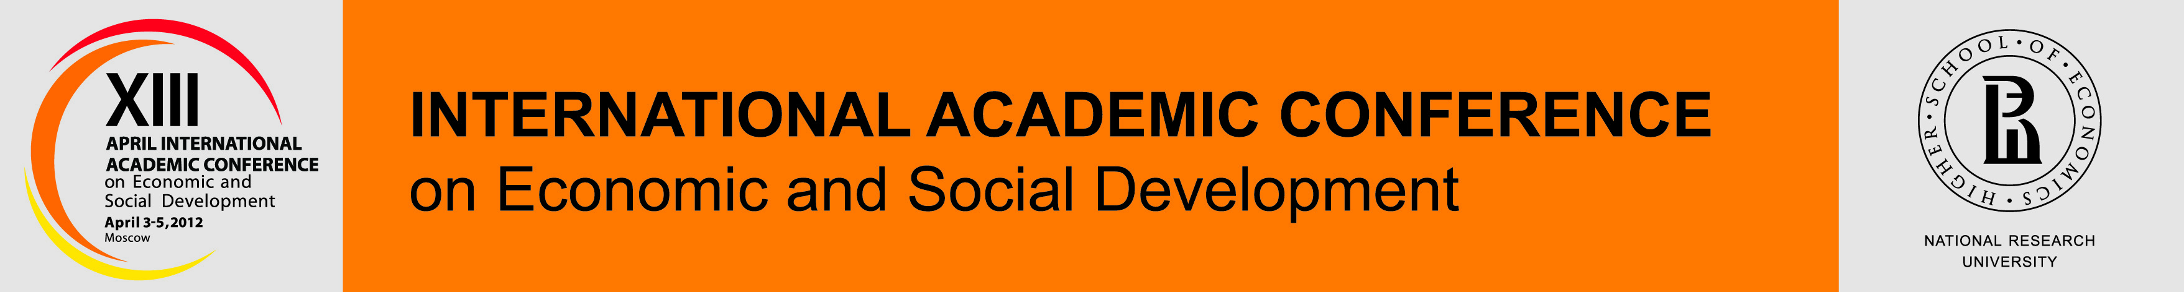

April 2, 10.00-13.30

**Plenary meeting**

**“Global Economic Crisis and Russian Economy”**

Moderators:

Evgeny Yasin (HSE Academic Supervisor)

Yaroslav Kuzminov (HSE Rector)

Alexander Shokhin (HSE President)

Lev Jakobson (HSE First Vice-Rector)

10.00 – Evgeny Yasin (HSE Academic Supervisor)

10.30 – Kaushik Basu (Senior Vice-president and Chief Economist of World Bank)

11.00 – Mikhail Abyzov (Minister for Open Government Affairs)

11.30 – Alexey Kudrin (Former Minister of Finance (2000-2011), Chairman of the Committee of Civil Initiatives)

12.00 – Marek Dabrowski (CASE)

12.30 - Andrey Fursenko (Assistant to President)

13.00 – Alexey Uliukayev (First Deputy Chairman of the Central Bank of Russia)