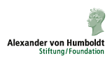
Humboldt-Kolleg

Rolle der Alexander von Humboldt-Stiftung in der Konsolidierung und Entwicklung der russischen Wissenschaft nach der Wende

Role of the Humboldt-Foundation in the consolidation and development of the Russian science during the transition

Moscow, 26.-28.02.2014
National Research University
Higher School of Economics

20, Myasnitskaya st.

Programm / Programme
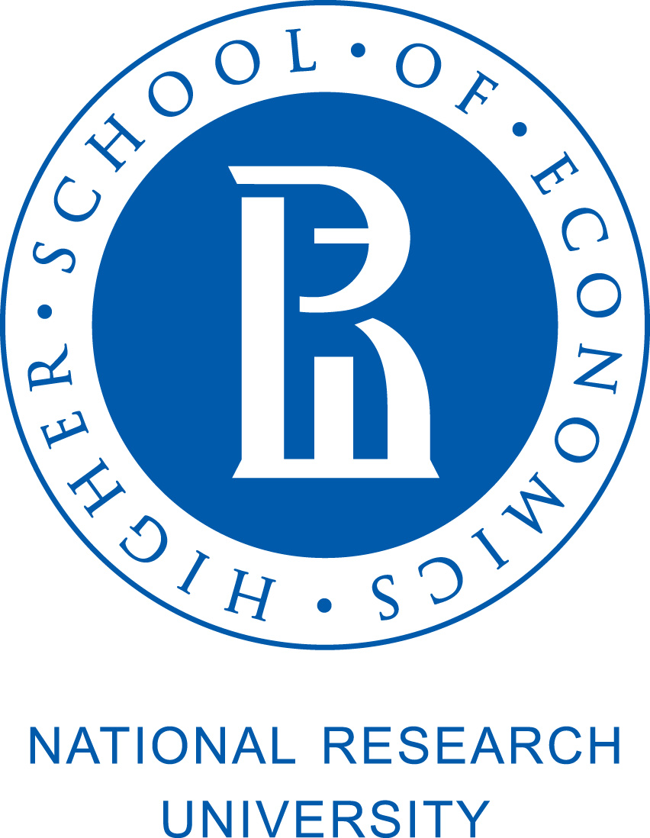
26.02.2014
Myasnitskaya, 20
9.30-10.00: registration start (lobby, 1st floor)
Myasnitskaya, 20,Raum/room 311 (10.00-13.00)
10.00: Grusswort / greeting – president of the Russian Academy of Science RAW Vladimir Fortov (requested)
10.10: Grusswort / greeting – representative of the FRG Embassy
10.20: Grusswort / greeting – rector of the HSE Yaroslav Kuzminov
10.30: AvH-network in Russia: Activities, importance for the Russian scientific community – President of the Moscow Humboldt-Club Prof. Dr. Viktor Zadkov

11.00- 13.00: Rundtisch /roundtable: Die ‚Mega-Grants‘ der russischen Regierung und die ‚Exzellenzinitiative‘ der Regierung der BRD und der Länder: Gemeinsamkeiten und Chancen für eine bessere Zusammenarbeit?/The ‚Mega-Grants‘ of the Russian Government and the Excellence initiative of the German Government and Länder: Commonalities and chances for a better co-operation?
Teilnehmer / Participants: Akad. Alexey Khokhlov (MSU), Dr. Gregor Berghorn (head, Moscow DAAD office), Akad. Sergey Lukyanov (Shemyakin-Ovchinnikov Institute of Bioorganic Chemistry), Prof. Mikhail Gelfand (MSU), Prof. Vladimir Tishkov (MSU), Galina Melnokova (Moscow DFG office), Prof. Alexandra Yurkovskaya (Novosibirsk State University)
Moderator – Prof. Alexander Chepurenko

13.00-14.30: Mittagspause / lunch (own disposal, cafeteria of the HSE or cafeterias around the HSE building, see last page)

Myasnitskaya, 20, Raum/room 101 (14.30-17.50)
14.30- 16.00: Alumni-Netzwerke – was sind sie und was machen sie?/ Alumni-networks: what they are and what they do? (chair – Prof. Viktor Zadkov)
- President of the Humboldt-Club St. Petersburg Prof. Boris Krylov
- President of the Humboldt-Club Kazan Akad. Kev Salihkhov
- President of the Association of former Federal Chancellor fellows in Russia Prof. Dr. Tatiana Nikitina
- Leiter des Verbindungsbüros der Freien Universität Berlin in Moskau / Head of Liaison Office of Freie Universität Berlin in Moscow Tobias Stuedemann
- Chief-editor Prof. Dr. Tatiana Ilarionova: Zeitschrift ‘Rußland-Deutschland’: warum und worüber? / Journal‚ ‘Russia – Germany‘: why and what about?

16.00-16.20: Kaffee-Pause / coffee-break
16.20-17.50: Deutsch-russische Zusammenarbeit in Forschung und Lehre: ‚Erfolgsstories‘ / German-Russian co-operation in research and education: success-stories. Chair – Ass. Member of the RAS Viktor Tsetlin
- Prof. Sergey Popel, Institut der Dynamik der Geospheren, RAS/ Moskauer Physisch-Technische Universität / Institute of Geospheres Dynamics, RAS / Moscow Institute of Physics and Technology / Space Research Institute, RAS: Russian - German Co-operation in the Fields of Space and Dusty Plasmas
- Anatoli Sidorenko, Ass. Member of the Academy of Science, Moldova, President, Humboldt-Club Moldova: Experience of Moldova-German scientific collaboration in frame of various programs and projects
- Dr. Elena Eremenko, Helmholtz-Stiftung, Moskau: Helmholtz-Society and its Role in German-Russian Co-operation (requested)
- Prof. Dr. Alexander Molochkow, Far Eastern Federal University: FEFU experience: What are the strategies of scientific communication that can solve the problem of development and internationalization?
Discussion

27.02.2014
Myasnitskaya, 20
9.30 –10.00: registration start (lobby, 1st floor)
Myasnitskaya, 20, Raum /room 101 (10.00-13.45)
10.00-11.30: Deutsch-russische Zusammenarbeit in Forschung und Lehre: ‚Erfolgsstories‘ / German-Russian cooperation in research and education: success-stories (Fortsetzung/continuation) Chair – Ass. Member of the RAS Sergey Nikitov
- Prof. Dr. Knud Nierhaus, Charité-Klinik, Berlin: Rescue of Stalled Ribosomes in Bacteria: The tmRNA Story
- Prof. Dr. Yuri Kovalev, Astrokosmisches Zentrum des Physik-Instituts der RAW / Astro Space Center of Lebedev Physical Institute, RAS: RadioAstron: Resolving Space Mysteries together
- Prof. Vlada Urlacher, University of Duesseldorf: Development of biocatalytic systems for production of fine chemicals
- Prof. Dr. Sergey Kuznetsov, HSE: Co-operation in applied mathematics
- Prof. Sergey Zaitsev, Moscow State Academy of Veterinary Medicine and Biotechnology: Multifunctional Supra-Molecular Systems in Research and Ph.D., Bachelor and Magister Programs of Biochemistry and Bio-nanotechnology: Russian-German cooperation
Discussion

11.30-11.45: Kaffee-Pause / coffee-break

11.45-13.30 Deutsch-russische Zusammenarbeit in Forschung und Lehre: ‚Erfolgsstories‘ / German-Russian co-operation in research and education: success-stories (Fortsetzung/continuation).Chair - Ass. Member of the RAS Mikhail Bibikov
- Ass. Member of RAS, Prof. Askold Ivantchik, Institut der allgemeinen Geschichte, RAW / Institute of World History, RAS: Die Reform der russischen Akademien und westeuropäische Modelle der Organisation der Wissenschaft / Reform of Russian Academies and West-European Models of Science Organization
- Asst. Prof. Dirk Meissner, HSE: International Labs in Russian universities: the case of the International Research Laboratory for Science and Technology Studies
- Dr. Sergey Erofeev, Vice-Rektor, HSE: Higher School of Economics: Co-operation with German excellence universities (requested)
Discussion
13.30-13.45: Dr. Steffen Mehlich, AvH: Schlußwort / concluding speech
14.00- 17.00: Empfang für Teilnehmer /reception for participants (Professoren-Club, Myasnitskaja, 20, 3. Etage / 3rd floor)

28.02.2014

Myasnitskaya, 20
9.30 –10.00: registration start (lobby, 1st floor)

9.30 – Beginn der Poster-Session / start of the poster session (Myasnitskaya, 20
lobby)

Myasnitskaya, 20, Raum /room 101
10.00-12.00:Image film about the Alexander von Humboldt-Foundation: http://www.humboldt-foundation.de/web/publikationen.html
Workshop with potential Humboldt fellows / Воркшоп с потенциальными заявителями на стипендии Фонда Гумбольдта на русском языке (д-р Андрей Яковлев, ВШЭ, д-р Штеффен Мелих, Фонд им. А. фон Гумбольдта)

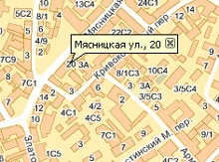

Standort / Venue – 20, Myasnitskaya, HSE (Main building)
WiFi in dem Gebäude / WiFi in the building
Login: Hseguest
Password: hsepassword

Metro stations close to the venue:
Turgenevskaya / Chistye Prudy (5 minutes walk), Kuznetsky most (5 minutes walk), Kitay-gorod (7 minutes walk)

Cafeteria and restaurants close to the venue:

Бочонок
Myasnitskaya, 24, building 3
Mollie"s Pub & Restaurant
Myasnitskaya, 13, building 3
Рахат-лукум
Myasnitskaya, 17
Дантес
Myasnitskaya, 13, building 3
Щербет
Myasnitskaya, 17, building 1

