**Cultural Diplomacy and Western Visitors to the Soviet Union, 1921-1941**

**"Культурная дипломатия Советского Союза и его западные гости, 1921—1941"**

**Higher School of Economics (Moscow)—Faculty of History**

**Prof. M. David-Fox**  
Проф. Майкл Шелдон Дэвид-Фокс

**March 10-14, 2015**

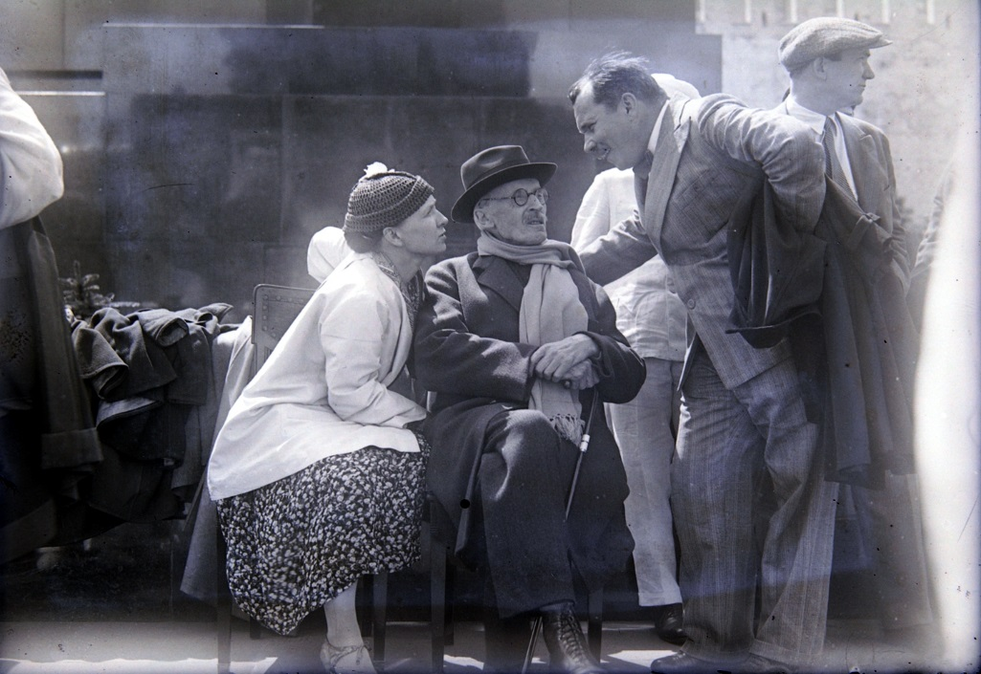

*Mariia Kudasheva-Rolland, Romain Rolland, Aleksandr Arosev on the Kremlin Mausoleum, 30 June 1935*

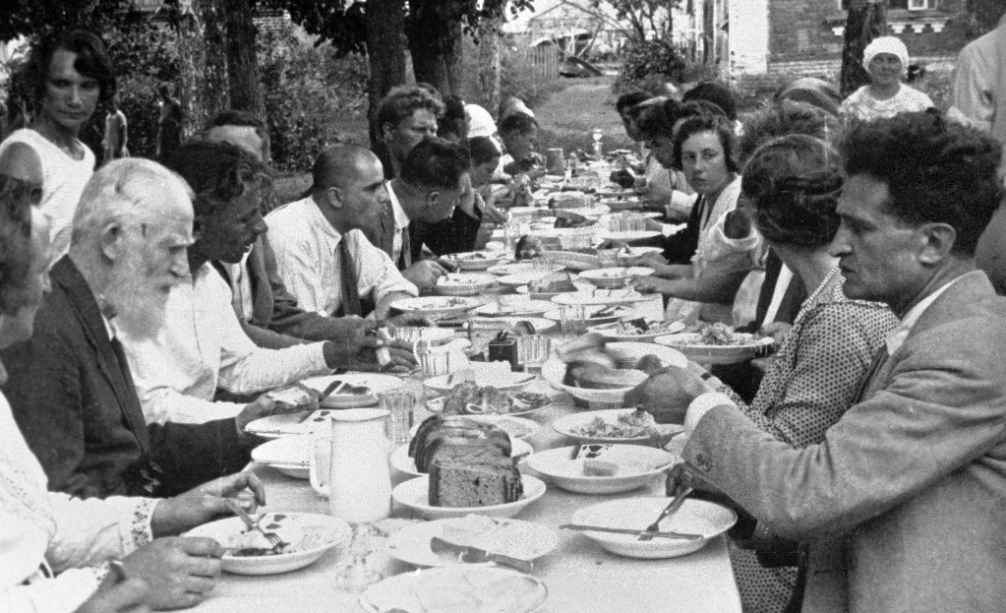

*Bernard Shaw (Second from Left), Kommuna im. Lenina, Tambov oblast’, 15 August 1931*

**Course Description:** This course will analyze the history of Soviet attempts to influence public opinion and influential opinion-makers in Europe and the United States during the heyday of Western enthusiasm for the “Soviet experiment” in the 1920s and 1930s. It will examine the Soviet system of showcasing Soviet socialism—both to visitors at home and in various ways abroad—in the context of the broader global history of “cultural diplomacy” and as a unique component of the Soviet system, one that illuminates central features of the Stalin-era domestic order. The course will center on a reading of the Russian translation of the instructor’s book*, Витрины великого эксперимента. Культурная дипломатия Советского Союза и его западные гости, 1921—1941* (<http://www.nlobooks.ru/node/5240>). Students will have the opportunity to discuss with the author how this historical monograph was planned, researched, and written.