Challenges to EU–Russia Economic Links

Course Syllabus and Description
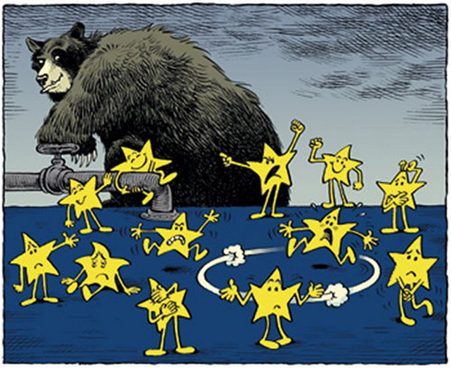 Prof. Vladimir Zuev
http://lipetskblog.ru

Author: Professor Vladimir Zuev
Section of Global governance and Regional Integration, World Economy and World Politics Faculty at National Research University – Higher School of Economics, Moscow, guest Prof. at Stanford University, guest Prof. at Sciences Po Bordeaux

General course information:
This course is designed for students with concentrations in Political Science and International Economics. This is an “upon a choice course” for international exchange students. The total workload for the course is 64 academic hours, including 16 academic hours (x45min=12 usual hours) in a class.
Prerequisites:
Basic economic knowledge and the knowledge of the European integration, as well as the knowledge of International Relations and International Economics form a prerequisite package.

Course abstract:
The course presents the analysis of the major challenges to the EU – Russia links. There is a clear contradiction between the huge potential for cooperation and the current state in relations, which are at a mess. This course, while disclosing the fundamentals and a historical retrospective of relations between Russia and the EU, is focused on the most recent developments in Europe, including unrest in Ukraine, and their impact on relationships in Europe. Large part of the course is dedicated to problems of economic cooperation, discovering the burden of economic sanctions. The aim is to understand the reasons for the current problems and to dress up the likely scenarios of the eventual development of links with largely unused potential for partnership.
Topics included in the course ignite discussion and debate. Different points of view on different aspects of the cooperation dilemmas are provided to create an objective vision of the controversial issue.

Methods of control and evaluation:
Class attendance and participation in discussions are required. Independent student’s work will consist of assimilation of theoretical material and information received within the course, learning the works of domestic and foreign authors on the given problems. Preparation of an essay (3-4 pages), or a PPP (10 slides) on a chosen topic is required.
Final grade is calculated on a cumulative basis from grades for:
- Lecture attendance - 0.2;
- Participation in the discussions and responses in the class - 0,3;
- an essay ("paper") of a maximum of 4 pages (15000 characters). The student will be required to hand this assignment in by e-mail before the end of the course directly to the teacher; or alternatively a power point presentation on the chosen topic - 0,5;
Students are given a mark (out of 10) and, if they pass, are awarded 3 ECTS

Course Topics
№ | Topic | Tot | Hours in a class | Home work
1. | Russia: a partner in transition. Problems of Russian economy integration in to the world economy. | 6 | 2 | 6
2 | History of the EU – Russia economic relations. Most important developments. PCA. | 8 | 2 | 6
3 | Major areas of cooperation. | 8 | 2 | 6
4 | The EU response to the Eastern threats | 8 | 2 | 6
5 | Most acute problems of the current economic links. Trade, investments, sectors, energy, sanctions. | 16 | 4 | 12
6 | Meeting new challenges. A new agreement. | 8 | 2 | 6
7 | RF in between Europe and Asia. Prospects of the EU – Russia partnership | 8 | 2 | 6
Tot |  | 64 | 16 | 48

Basic reading:
- OECD economic report on Russia. M.: OECD, 2016

Mitra P., SelowskyM. and others Turmoil at Twenty. Recession, Recovery and Reform in CEE and the former Soviet Union. Washington: WB, 2010.

IMF World Economic Outlook, October 2016. (www.imf.org/external/pubs/weo2016/02)

Jurgens I.. Russia in the twenty-first century: Model of a desirable future Internationale Politik und Gesellschaft, Issue 2, 2010, Pages 111-130

Energy for sustainable growth. UNDP report for Russia. M: 2010.

Matha Olcott. Vladimir Putin and Russia’s Energy Policy. Carnegie Moscow Center Working Paper, #1, 2005

The Geopolitics of Eurasian Economic Integration. London School of Economics,2014. http://www.lse.ac.uk/IDEAS/publications/reports/SR019
- Dmitri Trenin. Ukraine and the new divide. Carnegie Endowment. Moscow: 2014. http://carnegie.ru/2014/07/30/ukraine-and-new-divide/hln1
- Playing East against West. Charlemagne. Economist. Nov. 23, 2013. http://www.economist.com/news/europe/21590585-success-eastern-partnership-depends-ukraine-playing-east-against-west
- EU – Russia bilateral trade relations. European Commission. http://ec.europa.eu/trade/policy/countries-and-regions/countries/russia/
- Van der Loo, Guillaume (2013). "EU-Russia Trade Relations: It Takes WTO to Tango?". Legal Issues of Economic Integration 40 (1): 7–32. ISSN 1566-6573
- Vadim Kononenko The EU and Russia cease to be a priority for each other: the squabble over WTO membership reveals the defunct state of the strategic partnership. The Finnish Institute of International Affairs19.12.2012 http://www.fiia.fi/en/publication/305/the_eu_and_russia_cease_to_be_a_priority_for_each_other/
- Sergei Medvedev EU-Russian Relations - Alternative futures. 5.08.2006. http://www.fiia.fi/en/publication/26/eu-russian_relations-alternative_futures/
- Sergei Markov, How Russia and EU Can Build a Greater Europe. Moscow Times, Dec. 03 2013
- EMERSON, M. EU-Russia Four Common Spaces and the Proliferation of the Fuzzy. Brussels, 2005. CEPS Policy Brief. No. 71.
- EMERSON, M., TASSINARI, F., VAHL, M. A New Agreement between the EU and Russia: Why, what and when. Brussels: CEPS, 2006. Policy Brief No. 103.
- EU - Russia Trade and Investment: Practical Barriers : Survey/ Russian Chamber of Commerce and Industry. Brussels: Eurochambres, 2003.
- FORSBERG, T. The EU–Russia Security Partnership: Why the Opportunity was Missed // European Foreign Affairs Review. 2004. Vol. 9.
- http://eeas.europa.eu/russia/
- http://www.eu-russiacentre.org/

Sample Topics for essays or PPPs

- RF – EU trade
- RF – EU investments
- Scientific and technological cooperation
- Partnership for modernization (2009)
- Russian cos. in the EU
- EU cos. in Russia
- EU banks in Russia
- Role of euro in Russia
- Common European Economic Space
- Energy dialogue and energy security
- 3d energy directive
- Transport dialogue
- Economics of energy transportation in Eurasia.
- Agriculture dialogue
- Space dialogue
- Common standards
- Gradual introduction of visa free space.
- Human rights and civil society issues. Council of Europe and Russia – EU relations
- Common education space. Bologna process. Programs.
- RF and EU within global institutions
- Kaliningrad
- North dimension
- Eastern enlargement of the EU – consequences for Russia.
- EU neighborhood policy and Russia
- RF-EU business community Round table (1997-2017)
- Eurasian Economic Union and the EU
- Why the new EAE Union? (Current trends in economic relations between Russia, Byelorussia and Kazakhstan).
- Russia and Ukraine.
- EU sanctions on Russia
- Problems for the new EU –Russia economic agreement.

Note: The students are invited to come up with their own topics
Author…………………………..

