**Behavioral economics: from theory to practice**

dr. Nadezhda Shilova, Faculty of Economics Schiences, NRU HSE

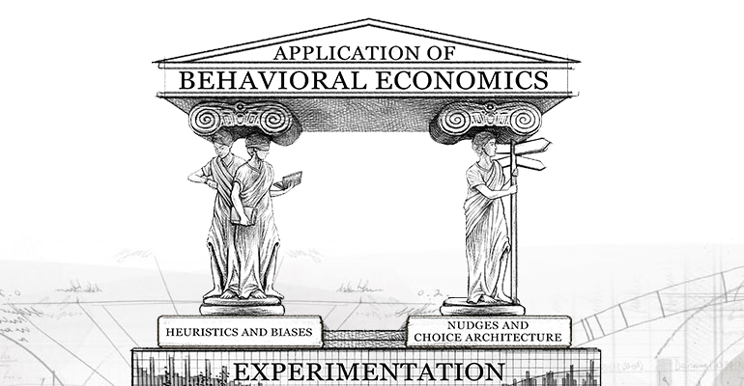

*Pre-requisites:* Students are supposed to be acquainted with the very basic economic concepts taught within the course of microeconomics; some basic knowledge on game theory is also welcomed but not obligatory.

*Course Type* (compulsory, elective, optional) elective/optional

*Abstract:* A usual complaint about economic theory courses we hear from students sounds like "but it does not work like this in real life!" Unfortunately, studying general cases takes too much time to explain that life is a special case of a general rule.

During the suggested course we will try to reconcile theory and practice: we will see how mental and emotional filters shape the choice people make personally and as a group. We will also try to understand what is rational choice and you will formulate for yourself what rational patterns to follow (or not to follow) in real life whenever you'll have to make a decision - as a consumer or as a producer or even as a governor.

*Learning Objectives:* Deeper and broader understanding of behavioral patterns; improving own decision making schemes and making better decisions.

*Course Plan:*

|  |  |  |  |  |
| --- | --- | --- | --- | --- |
| **№** | **Topics** | **Academic/Contact Hours** | | **Self-study Hours** |
| **Lectures** | **Labs** |
| 1. | Homo Economicus: the concept of rationality in economics. Rationality VS egoistic behavior. | 2 | 2 | 2 |
| 2. | Why economics needed psychologists. Reshaping cognitive schemes. Heuristics. | 4 | 2 | 4 |
| 3. | What also influences our choice: emotions, institutions, what else? | 2 | - | 2 |
| 4. | Decisions under uncertainty. Probabilistic mistakes. | 2 | 2 | 2 |
| 5. | Well-being and happiness: what is everything for? Notion of rationality – again. Nudges. | 4 | 2 | 4 |
| 6. | Projects presentation | 2 | - | 4 |
| sum | **44** | 24 | | 18 |

*Reading List (by topics):*

**Topic 1. Homo Economicus: the concept of rationality in economics. Rationality vs egoistic behavior.**

Rationality and axiomatics of consumer choice in economics. Maximization of utility within constraints. Choice between all available alternatives. Egoistic reasoning and/or egoistic outcome: why does a baker bakes those supertasty cakes that I like so much? From A.Smith to G.Becker.

Economic modeling as a scientific method. History of economic thinking as a history of economics as science. Modeling everything: economics of dating, marriage and divorce, economics of crime and punishment, economics of discrimination.

**Reading List:**

1. Binmore, K. (2009) Rational Decisions. Princeton University Press.
2. Gilboa, I. (2010) Rational Choice. MIT Press.
3. Hammond, J. S., Keeney, R. and Raiffa, H. (1998) Smart Choices: A Practical Guide to Making Better Decisions. Harvard Business School Press.

**Topic 2. Why economics needed psychologists. Reshaping cognitive schemes. Heuristics.**

First experiments and their results: trying to explain the (ir)rational behaviour. H.Simon and his works. Bounded rationality. Heuristics: heuristics of representativeness, availability heuristics, anchoring, framing effect, dynamic inconsistency and others.

Class experiments: their rules. Psychological vs economic experiment.

**Experiments.**

**Reading list:**

1. Ariely, D. (2008) Predictably Irrational. MIT Press.
2. Sent, E. M. (2004). Behavioral economics: how psychology made its (limited) way back into economics. History of Political Economy, 36(4), 735-760.

**Topic 3. What also influences our choice: emotions, institutions, what else?**

What is emotion. Ways to classify emotions and emotional reactions. How different emotions influence our choice. Are we content with the emotional choice?

Introductions to institutional economics. Institutions which rules we follow consciously and unconsciously: laws and traditions. Are traditions rational? What is the difference between people and animals in ways they follow institutional rules? Who constructs rules?

Influence of friends, parents, relatives, charismatic people… Political manipulations.

**Reading list:**

1. Elster, J. (1998). Emotions and economic theory. Journal of economic literature, 36(1), 47-74.
2. Elster, J. (1989). Social norms and economic theory. Journal of economic perspectives, 3(4), 99-117.
3. Loewenstein, G. (2000). Emotions in economic theory and economic behavior. The American Economic Review, 90(2), 426-432.
4. Zeelenloerg, M., & Pieters, R. (2013). to the Study of Emotions in Economic Behavior. Social psychology and economics, 117.

**Topic 4. Decisions under uncertainty. Probabilistic mistakes.**

Uncertainty in our life. Breaking the full information assumptions.

Probability. Lotteries. Basics of combinatorics. Bayes theorem. Systematic mistakes in evaluating probabilities and using prior information while forecasting posterior. Mistakes in evaluating probabilities of statistically dependent and independent events.

Subjective probability. Availability heuristics – again. Causality. The Sure Thing Principle.

Von Neumann and Morgenstern’s result. Basics of prospect theory.

**Experiments.**

**Reading List:**

1. Karni, E. (1985) Decision Making Under Uncertainty: The Case of State Dependent Preferences. Harvard University Press.
2. Ellsberg, D. (1961) Risk, ambiguity and the Savage axioms. Quarterly Journal of Economics, 75, 643–669.
3. Knight, F. H. (1921) Risk, Uncertainty, and Profit. Houghton Mifflin.
4. Dobbs, I. M. (1991) A Bayesian approach to decision-making under ambiguity. Economica, 58, 417–440

**Topic 5. Well-being and happiness: what is everything for? Notion of rationality – again. Nudges.**

Welfare economics – is it the only way to make people happy? What is happiness and can it be measured in economic terms? Fairness and equality.

Postrationalising – a way to become happier? Rethinking the rationality again.

Nudges in everyday life: in medicine, in encouraging healthier behavior, in triggering savings.

**Experiments.**

**Reading List:**

1. Brickman, P., Coates, D. and Janoff-Bulman, R. (1978) Lottery winners and accident victims: is happiness relative? Journal of Personality and Social Psychology, 36, 917–927.
2. Easterlin, R. (1973) Does money buy happiness? The Public Interest, 30, 3–10
3. Diener, E. (1984) Subjective well-being. Psychological Bulletin, 95, 542–575.
4. Shilova, N. (2013). How Politicians Exploit and Manipulate People's Perceived Well-being to Win in the Political Arena and to be Elected. In The Happiness Compass: Theories, Actions and Perspectives for Well-Being (pp. 263-272). Nova Science Publishers.

**Last days: 6. Projects presentation**

*Assessment:*

The students are supposed to present their own projects in the end of the course. The projects might be done by one student alone or in groups of 2-3 students. To submit a good project, students should read suggested literature and participate in discussions in class. The good project is the one that is both comprehensive, based on the previous researches, and deep and detailed on the particular features of human economic behavior.

Final grade is calculated as follows:

• Project presented 0.7;

• Lecture attendance and discussion participation 0.3.

For each of the above aspects of evaluation the student receives, correspondingly, on a 10-point scale:

• For the project —0.7 x Q1;

• For lecture attendance and discussion participation —0.3 x Q2;

where Q1, Q2 are grades on a 10-point scale.

NOTE! During the course the students will be actively participating in experiments. Experiments are not aimed at grading, they are aimed at getting the data to discuss in class.

*Methods of Instruction:* interactive lectures, laboratory experiments, labs (discussions)