**TEACHING LIFE HACKS (FROM ICELT CAMBRIDGE APPROACH)**

Teaching approaches:

* Teacher Fronted Approach
* Test-Teach-Test
* Guided Discovery
* Skill-oriented Approach

**Factors Affecting Learning**

|  |  |
| --- | --- |
| Outside learners | Inside learners |
| The learning environment | Reasons for learning |
| Teaching methods | Students’ learning preferences |
| Teaching material | Student’s personality, gender, background |
| Other students | Other factors |
| The teacher |
| Other factors |

A good course for students should be...

**1. practically oriented**

exposure to the studied course

different learning practices

skill-oriented

**2. supported**

by praise

by the students reflecting on learning

by asking appropriate questions

by providing them with helpful material

**3. meaningful**

it builds on what the students already know

it makes sense and is relevant to students

it fits into a natural, real or understandable context

they can see and relate to the reasons for doing it

**4. purposeful**

students are given the chance to work things out for themselves

activities are appropriate challenging

it develops critical thinking and dicision making

**5. enjoyable**

it arouses curiosity

it sparks interest and attention

activities lead to success

there is a sense of fun

**6. social**

students are encouraged to co-operate, respect and help each other

there is a sense of community (pair work and team work)

Soft skills development

* Communication skills
* Interpersonal
* Public speaking
* Leadership
* Conflict management
* Decision making
* Time management
* Stress management

Engage students (pictures, video, reading, listening, prediction, brainstorming, games, etc.)

Support Students for generating ideas

Provide feedback on the achievement of the task

**Note taking methods**

* Mind map
* Outlining
* Cornell
* Charting

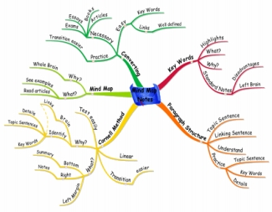

***When taking notes, you are not***

***simply copying out information***

***neatly. Rather, you are transforming***

***that information into knowledge***

***according to your needs.***

**Taking notes from texts**

**Effective, transformative note taking is a key step in assignment writing & exam preparation**

**Why take notes?**

A fundamental reason for taking notes is to enhance your comprehension and retention of the content of a text. The ability to put another’s ideas and explanations into your own words as a summary and/or paraphrase, or to transform a written text into a flow chart or mind map, demonstrates whether you have understood the material you have been reading.

Other reasons for taking notes are:

• to note down a statement that you wish to quote in an essay

**Diagrammatic approaches**

When you don’t have your own copy of a text, a **diagrammatic** approach –creating an outline or a map of the contents –can be a useful record of your reading.

**Outlining** involves writing down an author’s main ideas, supporting ideas and evidence, in point form. Copy down the headings and subheadings of the text to use as the framework for your outline, and add more detail in dot-point form as you read. NB: MS Word includes an outlining function which is very useful both for note taking while reading, and for planning your own writing (see the View menu, and look

•

•

to summarise an argument in a text for future use in an essay, exam or tutorial

to register questions and comments that you have while reading, which may be forgotten or overlooked later.

up ‘About Outline View’in the MS Word Help file).

After you’ve read a text, you might want to construct a **mind-map**, **concept map** or **chart** from it.

The notes you take make while reading and researching may well end up in the final draft of an assignment. Those you make when studying, ideally, can become the foundation for exam revision at the end of semester.

***Nevertheless, there is no one correct way to take notes.***

**Marking up (annotating) a text**

One approach to note-making is to **underline** or **highlight** keywords or sections of a text, to use post-it notes or page stickers to distinguish ideas, and/or to make brief **notes** in the margins or between the lines of the text. Done with care, this can help you to concentrate and focus on what you are reading, and it may help you to identify the key points of a text when you are re-reading it later for an exam or an essay. However, it is not a particularly *transformative* approach to note-taking.

1. ource: Using Mind Maps (2012) www.usingmindmaps.com
2. his is useful for reviewing material or for gaining an overview of a topic. It involves manipulating the ideas and information, which is likely to improve your understanding of the material. Concept maps work best when you use colours and images, revealing the relationships between concepts by proximity and connections.

**Academic Skills**

www.services.unimelb.edu.au/academicskills • 13 MELB • academic-skills@unimelb.edu.au

*Go for excellence*

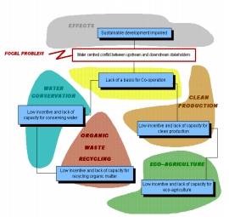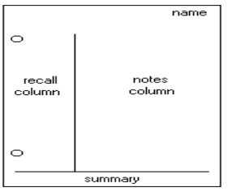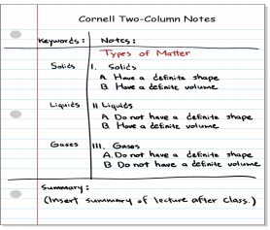

First, ***record*** ideas while reading in the notes column. Then ***reduce*** these notes to basic concepts and details; possibly turn answers into questions, in the recall column. Next, cover the main notes column and attempt to ***recite*** the details from the basic concepts and the questions in the recall column. It is important to ***reflect*** on ideas or connections that emerge. Take note of such reflections in a separate document. Finally, spend 10 minutes or so regularly ***reviewing*** these notes while researching an assignment or revising. Further reflections that emerge should be recorded.

1. ource: International Institute for Sustainable Development (2012) <http://www.iisd.org/sdcn>
2. **ransformative approaches**

Transformative approaches involve reproducing the **content** of a text **in different words**.

• A **paraphrase** involves saying the same thing as the author, *but in your own words*. Much of your essay writing will involve paraphrasing ideas from the sources you have read. (Note that a paraphrase can be longer than the original text.)

•

A **summary** is a restatement of the main points of a text in (much) shorter form. A summary should answer the question, “What is the author basically saying?” It should remain faithful to the author’s emphasis and interpretation, and should not contain your own opinions or comments.

Source: Orange County Public Schools (2012) www.ocps.net **Review**

After you have completed taking notes from a text, it is important to review your notes, particularly notes you expect to use later for an essay or exam.

**Cornell approach**

• Are they readable?

• Are they accurate?

A Cornell approach divides your page into two columns and a horizontal space along the bottom.

Source: Orange County Public Schools (2012) www.ocps.net

•

•

•

•

Are they complete enough for your purposes?

Are there any concepts you don’t understand? Have you included all bibliographic details?

Can you clearly distinguish between direct quotes, paraphrases and your own ideas?

This system emphasizes the 5R’s of note-taking: **record**, **reduce**, **recite**, **reflect** and **review**.

**Works Cited**

Using Mind Maps. (2012). Retrieved from www.usingmindmaps.com

International Institute for Sustainable Development. (2012) Retrieved from <http://www.iisd.org/sdcn>

Orange County Public Schools. (2012). Retrieved from www.ocps.net **Further Resources**

For the Cornell system iPad app, see: <http://www.applgasm->apps.com/cornell_notes.html

De Fazio, T. (2002) *Studying part time without stress*, Sydney: Allen & Unwin.

Marshall, L., & Rowland, F. (1998). *A guide to learning independently* (3rd ed.), Melbourne: Addison Wesley Longman.

**Academic Skills**

www.services.unimelb.edu.au/academicskills • 13 MELB • academic-skills@unimelb.edu.au

*Go for excellence*

*V2 1112 JH*