*Math model*

Let $U$ be a set of objects. For each $u ∈U$ correspons an ordered n-tuple

$$Z_{u}=\{0≤z_{u}^{i}≤1\}_{i=1}^{n}$$

Let us construct a «curve» which goes through points $\{z_{u}^{i}\}_{i=1}^{n}$, the function

$$f^{u}: R→R$$

$$∀i∈\left[1, n\right]∩N: f^{u}\left(i\right)=z_{u}^{i}$$

$$∀i∈\left[1, n-1\right]∩N:$$

$$f^{u}\left(x\right)=k_{i}^{u}x+b_{i}^{u}, ∀x∈\left(i, i+1\right)$$

Where $\left\{\begin{aligned}f^{u}\left(i\right)=k_{i}^{u}i+b_{i}^{u} \\ f^{u}\left(i+1\right)=k_{i}^{u}(i+1)+b_{i}^{u}\end{aligned}\right.$

The tuples are displayed now in parallel coordinates (Fig. 1).

Fig. 1

The tuples can be clustered by absolute values (Fig. 1) and by tangents of slope angles (Fig. 2).

Fig. 2

In the first case, each object $u$ is assigned a vector $v_{u}$ of tuple values of demission $k=n$.

$$V=\{v_{u} |∀i∈\left[1;k\right] 0≤v_{u}^{i}≤1\}$$

In the second case, each object $u$ is assigned a vector $v_{u}$ of demission $k = n - 1$ of tangents of the slope angles of the chart relative to the abscissa axis. Next, the tangent vector of the slope angles is displayed in parallel coordinates. The tangents of the slope angles take values from -1 to 1 (Fig.3).

$$V=\{v_{u} |∀i∈\left[1;k\right] -1≤v_{u}^{i}≤1\}$$

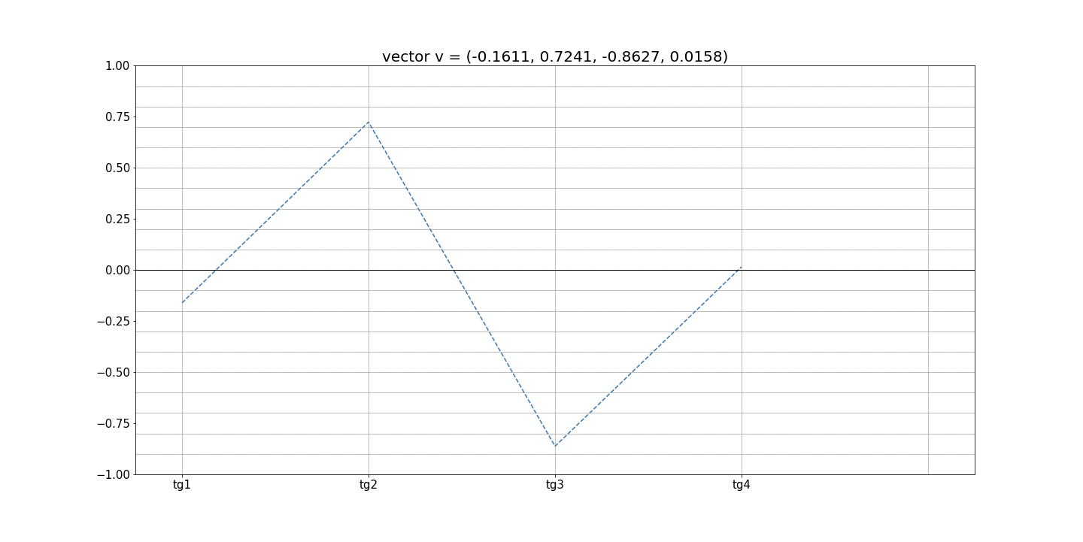

Fig. 3

The first type of clustering considers both the scale of the curves and their shape, and the second considers only the shape.

Each vector $v_{u} ∈V$ can generate a cluster $K\left(v_{u}\right)$. $v_{u}$– generating vector. A $δ$-tube is constructed around the curve of vector $v_{u}$. Where $δ$ is a vector of values of predefined width of the tube for each coordinate $δ_{i}$.

$$δ=\{0≤δ_{i}≤1\}_{i=1}^{k}$$

All the vectors $v_{u^{'}}$ whose curves get into the $δ$-tube are grouped into one cluster (Fig. 4-6).

$$∀v_{u^{'}}∈V v_{u^{'}}∈ K\left(v_{u}\right)⟺(∀i≤k \left|v_{u^{'}}^{i}- v^{i}\right|<δ_{i})$$

There are three types of $δ$-tube: fixed tube, adaptive tube, combined tube. The width of $δ$-tube depends on the parameters $ε$ and .

- deviation coefficient

- minimum permissible deviation

Fixed tube. $δ_{i}= ε$. The width of the tube is constant and preset (Fig. 4).

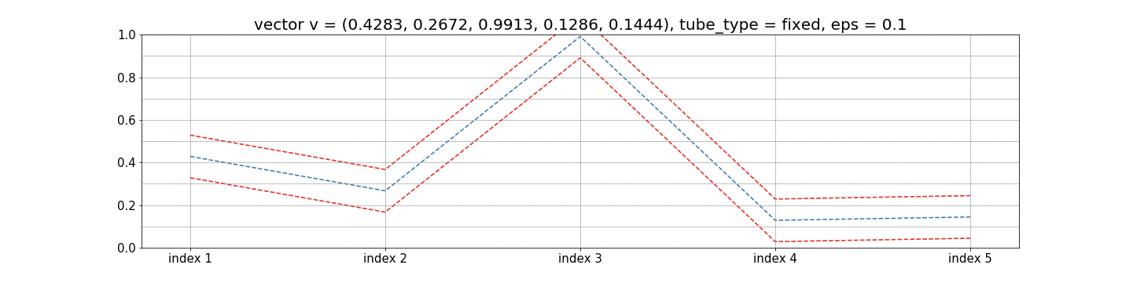

Fig.4

Adaptive tube. $δ_{i}= ε\left|v_{i}\right|+h$. The width of the tube is directly proportional to the vector defining the cluster (Fig. 5).

Fig. 5

Combined tube. $δ_{i}= ε\max_{i}\left|v_{i}\right|+h$. The width of the tube is fixed and directly proportional to the maximum modulus of the values of the vector forming the cluster (Fig. 6).

Fig. 6

During the clustering algorithm choose a generating vector among vectors which haven’t get into any cluster yet. The vector generates a new cluster.

The clustering is started $t$ times. Among the clustering results, the one that minimizes the functionality is selected.

Consider $X$ clustering. $X= \{X_{i}\}_{i=1}^{i=m}$

$$\frac{\sum_{X_{i},X_{j}∈X}{E\left(X_{i}, X_{j}\right) }}{m^{2}}- \frac{\sum_{X_{i}∈X}{ρ\left(X_{i}\right) }}{m}$$

Where

$$E\left(X_{i}, X_{j}\right)= ρ\left(p_{i}, p_{j}\right)$$

Euclidean distance between the mean vectors of the cluster

$$ρ\left(X_{i}\right)= \frac{\sum_{v_{u}∈X_{i}}{ρ\left(p_{i}, v_{u}\right) }}{|X_{i}|}$$

The average of the Euclidean distances from the cluster vectors to its center

*Input data and the interface*

At first, enter the password (Fig. 7).

Fig. 7

If your password is correct, you will be able to upload data for clustering and numbers of patterns in case they have already been counted (Fig. 8).

Fig. 8

Fig. 9

Field “Upload data”

Input format: csv-file with separator comma where the first column contains the names of the objects, the first row contains the names of the indexes. The remaining rows contain the name of the object in the first column and the index values from 0 to 1 in others.

If you upload data you will be shown (Fig. 9):

1. Field “Groups of patterns to union”
2. Field “Group of patterns to apply clustering to”
3. Button “Apply clustering to the entire sample”
4. Field $E$
5. Field $h$
6. Field $t$
7. Drop-down menu “Type of values for clustering”
8. Drop-down menu “Type of tube”
9. Link “Download numbers of patterns”
10. Button “Calculate patterns”
11. Button show list of patterns”
12. Button “Draw interactive charts”
13. Button “Download charts as zip”

You can upload new data later. In such case the numbers of рattern will be reset.

Field “Upload data numbers of patterns”

Input format: csv-file with separator comma where the first column contains the names of the objects, the second column contains the numbers of clusters for each object. The first row contains the names of the two columns.

In case the names of the objects uploaded in the “Upload data” field and the “Upload data numbers of patterns” field won’t match each other, the data will be reset.

If you upload numbers of patterns without data or the data will be reset you will be shown (Fig. 10):

1. Field “Groups of patterns to union”
2. Link “Download numbers of patterns”
3. Button show list of patterns”

Fig. 10

Field “Groups of patterns to union”

Input format: groups of patterns separated by semicolon. Each group contains numbers of patterns separated by a space, which must be united into one pattern.

After pressing Enter, the pattern objects of each group are united into a new pattern. All new patterns are numbered in the order of enumeration of the groups corresponding to them (starting from 0). The numbers of all other patterns are shifted by the corresponding number.

Field “Groups of patterns to apply clustering to”

Input format: numbers of patterns separated by space.

After pressing Enter, the pattern numbers, which clustering will be applied to, will be displayed on the line under the parameter input fields.

Button “Apply clustering to the entire sample”

After pression on the button the string “entire sample” will be displayed on the line under the parameter input fields. The clustering will be applied to the entire sample.

Field $E$.

Input format: $E$ value, decimal number separated by a dot.

After pressing Enter, the $E$ value will be displayed on the line under the parameter input fields. The clustering will be applied with this value of $E$.

Filed $h$.

Input format: $h$ value, decimal number separated by a dot.

After pressing Enter, the $h$ value will be displayed on the line under the parameter input fields. The clustering will be applied with this value of $h$.

Drop-down menu “Type of values for clustering”.

Choose the type of values: absolute values or tangents of slope angles.

After choosing, the type of values for clustering will be displayed in the line under the parameter input fields.

Drop-down menu “Type of tube”.

Choose the type of values $δ$-tube: fixed tube, adaptive tube, combined tube.

After choosing, the type of tube will be displayed in the line under the parameter input fields.

Line with parameters of clustering.

Parameters of clustering are displayed here.

Link “Download numbers of patterns”

Output format: csv-file with a comma separator, the first column of which is the names of objects, and the second is the numbers of patterns. The first row contains the name of these two columns: “Object” and “Pattern".

Button “Show list of patterns” / “Hide list of patterns”

After pression on the button you will find the total amount of objects in each pattern. Click on the button again to hide it (Fig.11).

Button “Draw interactive charts”.

After pressing on the button you will see the interactive charts (Fig. 12).

Scroll down the page to see all the charts (Fig.13).

Click on a curve ones to hide it. Click on it again to show it (Fig.14).

Click on a curve twice to hide all other curves on the chart. Click on again to show all other curves (Fig.15).

There is a toolbar for each chart on the upper right corner of the chart, there are names of objects in the legend, there is a number of pattern in the title of each charts, and there are index names on the Ox axis (Fig.16).

Hover the cursor over the top of the curve to see the name of the object, the name of the index and its value for this object (Fig.17).

Button “Download charts as zip”.

Output format: zip- file that contains all the drawn charts in png format.

Fig. 11

Fig. 12

Fig. 13

Fig. 14

Fig. 15

pattern number

index names

object names

toolbar

Fig. 16

Fig. 17