RATIONAL AND NORMATIVE DIMENSIONS OF NATIONAL PRIDE IN COMPARATIVE PERSPECTIVE
Marharyta Fabrykant (Higher School of Economics), Vladimir Magun (Institute of Sociology of the Russian Academy of Sciences, Higher School of Economics)

Appendix 1

Standard deviations of the three measures of national pride

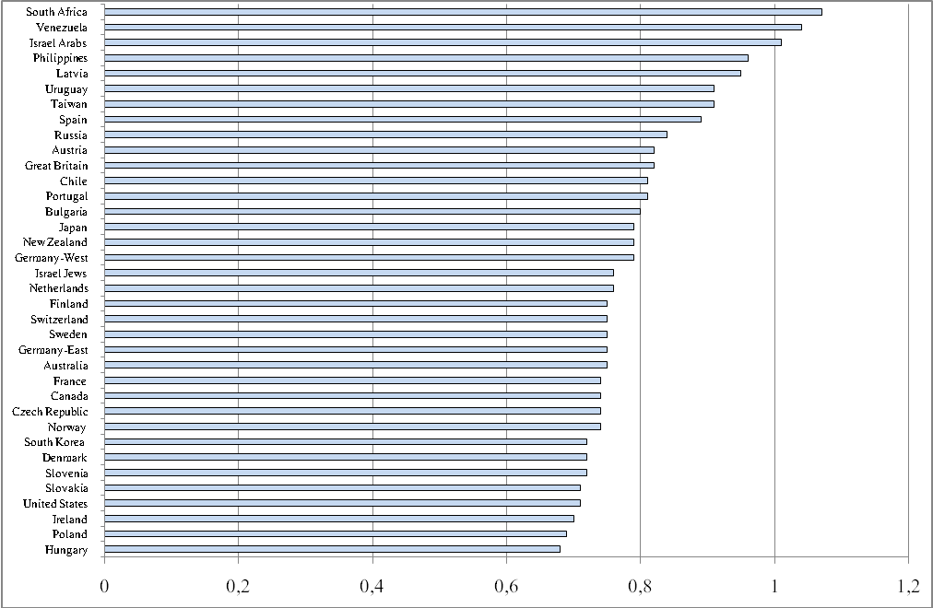
Figure 1.1. Country standard deviations of the domain-based factor estimate of general national pride

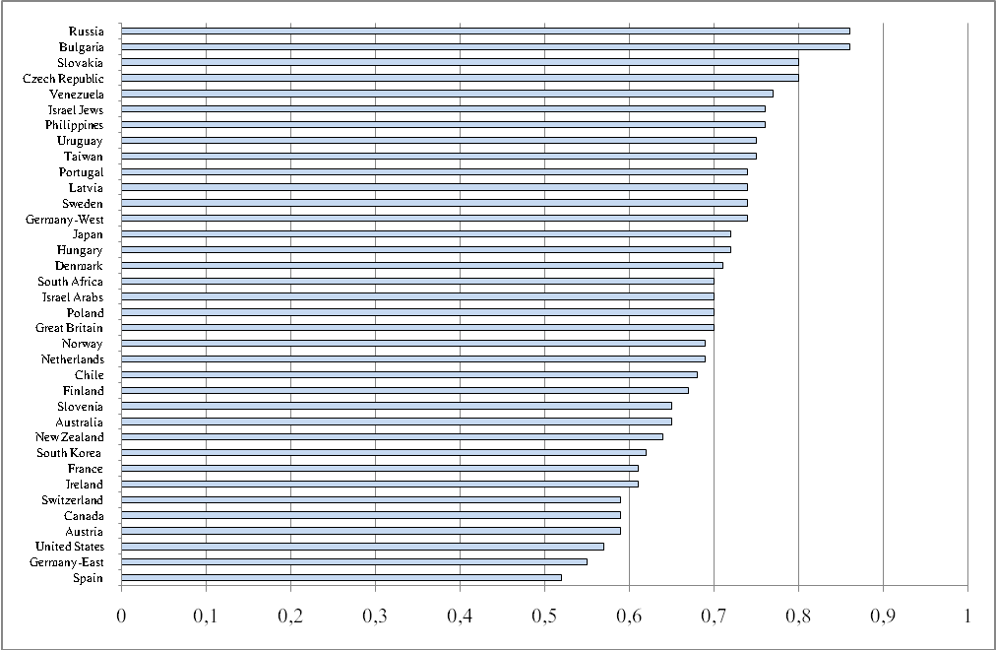
Figure 1.2. Country standard deviations of the factor of the inverse relations between the pride in elitist and mass country achievements

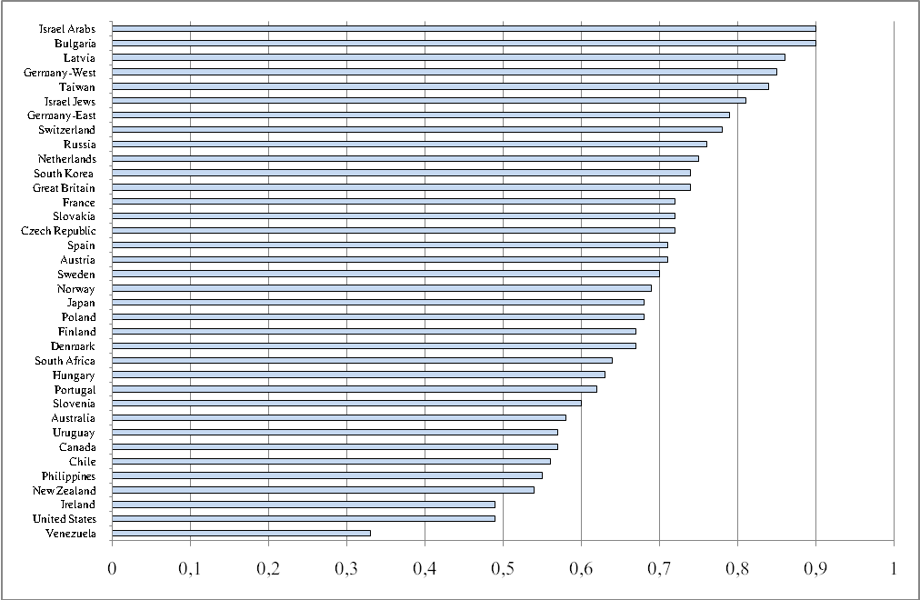
Figure 1.3. Country standard deviations of the direct single-item estimate of general national pride

Appendix 2

Descriptive Statistics on Pride in Specific Achivements

Figure 2.1. Country average scores on the way democracy works in the respondent’s country (the higher the scores the higher the pride)

Figure 2.2. Country standard deviations of the pride in the way democracy works in

the country

Figure 2.3. Country average scores on the pride in the country’s political influence in the world

Figure 2.4. Country standard deviations of the pride in the country’s political influence in the world

Figure 2.5. Country average scores on the pride in the country’s economic achievements

Figure 2.6. Country standard deviations of the pride in the country’s economic achievements

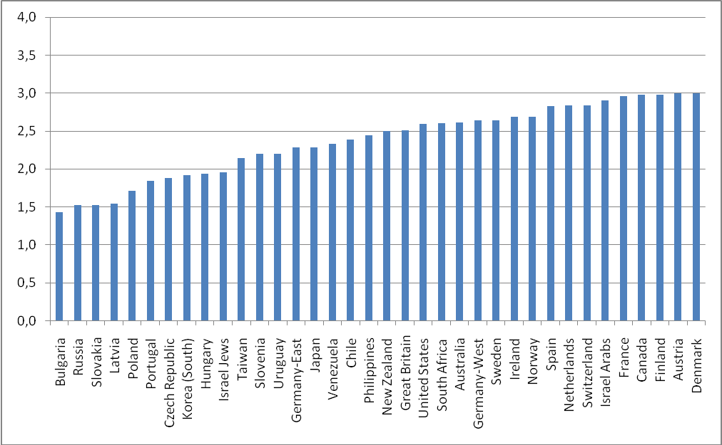

Figure 2.7. Country average scores on the pride in the country’s social security system

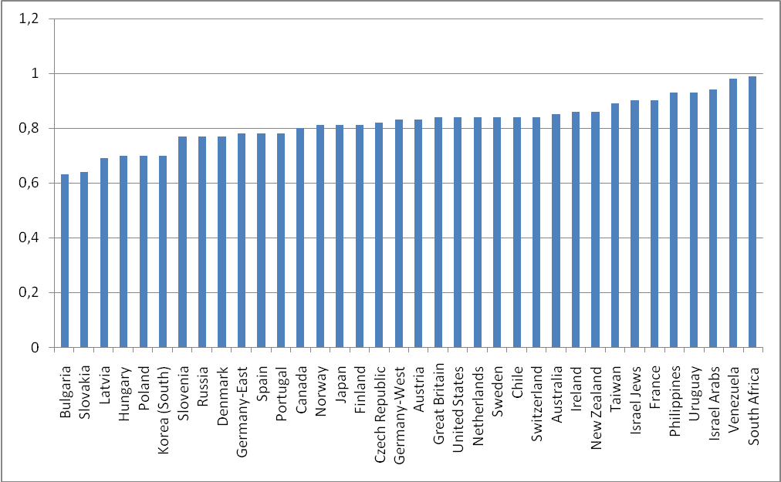
Figure 2.8. Country standard deviations of the pride in the country’s social security system

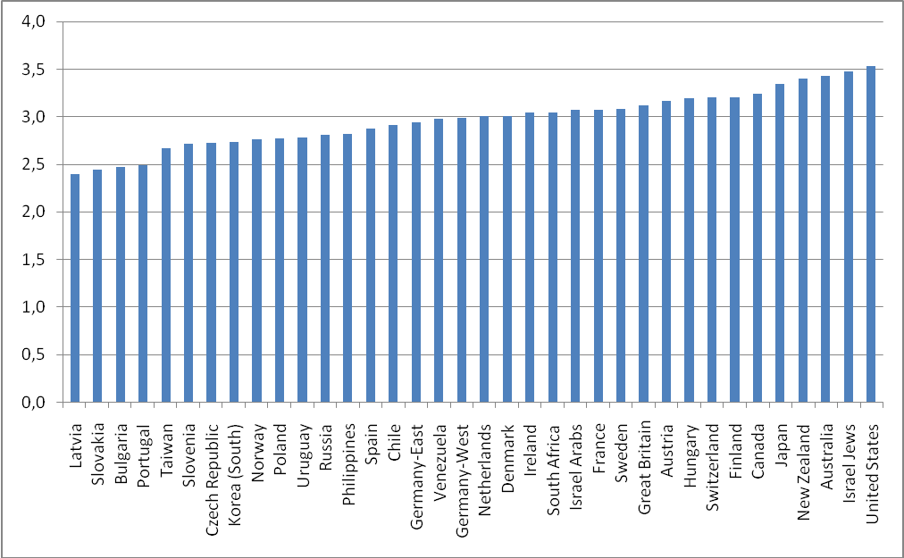

Figure 2.9. Country average scores on the pride in the country’s scientific and technological achievements

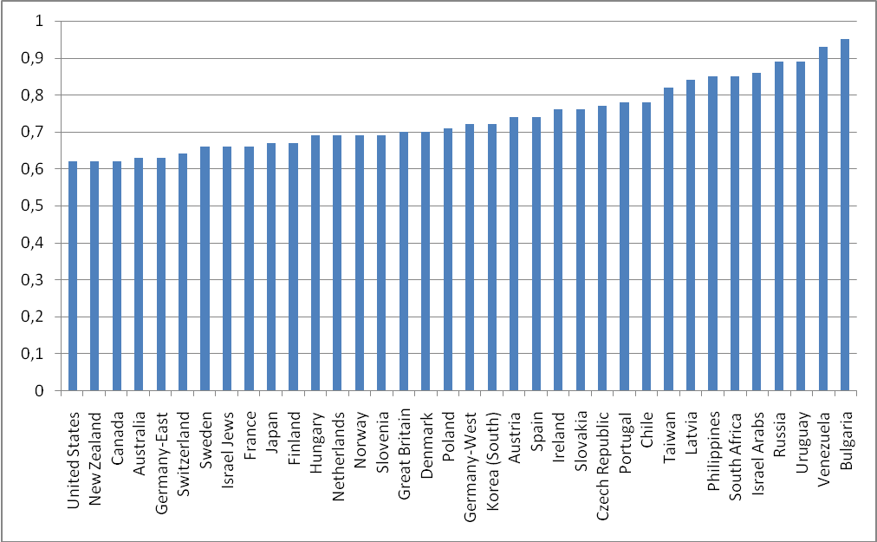
Figure 2.10. Country standard deviations of the pride in the country’s scientific and technological achievements

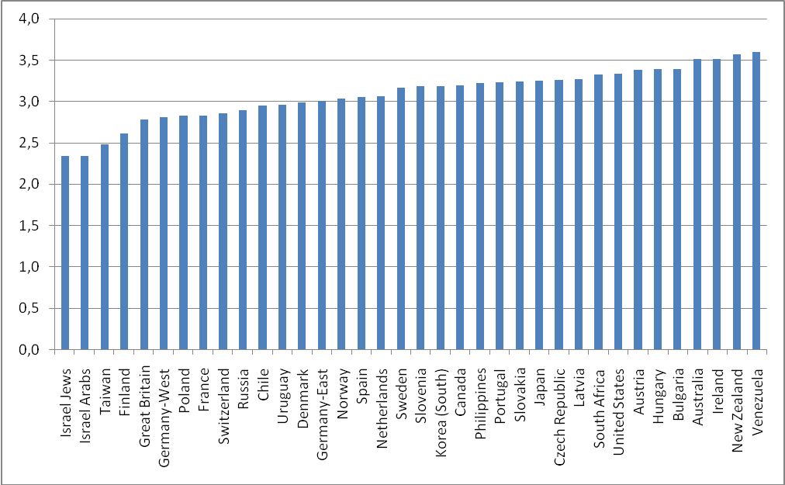

Figure 2.11. Country average scores on the pride in the country’s achievements in sports
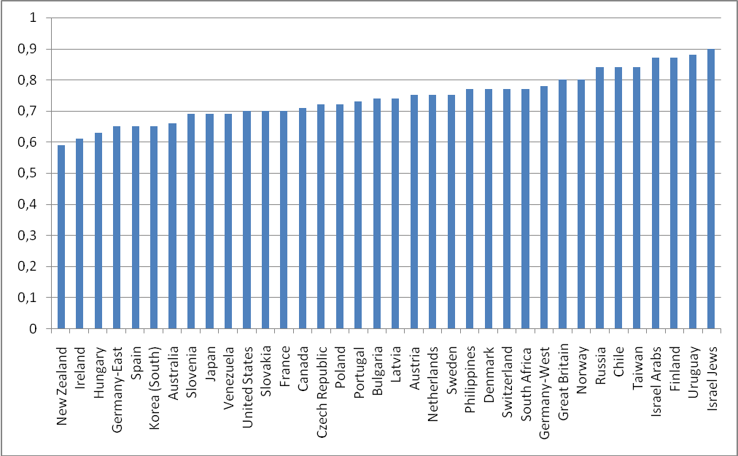
Figure 2.12. Country standard deviations of the pride in the country’s achievements
in sports

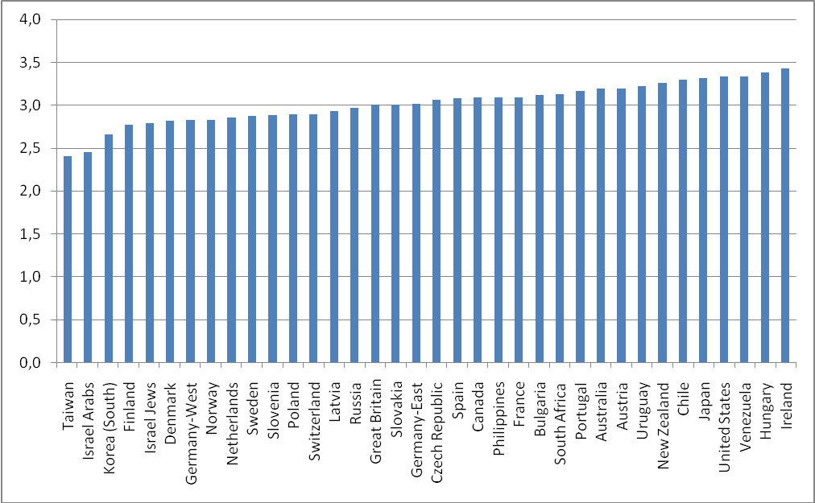

Figure 2.13. Country average scores on the pride in the country’s achievements in the arts and literature

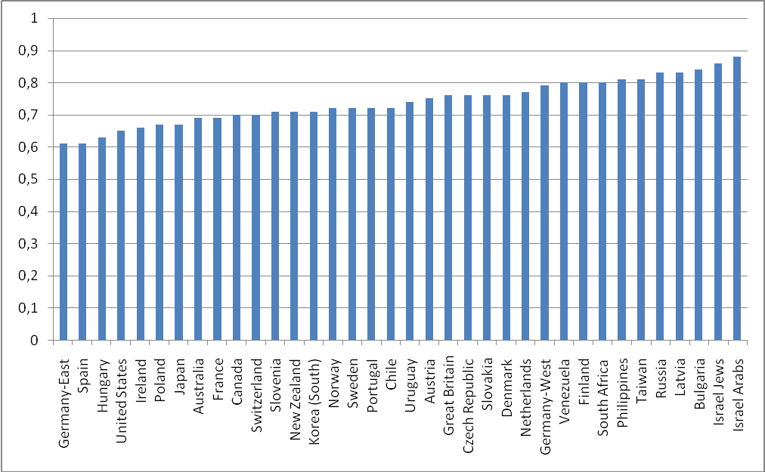
Figure 2.14. Country standard deviations of the pride in the country’s achievements in the arts and literature

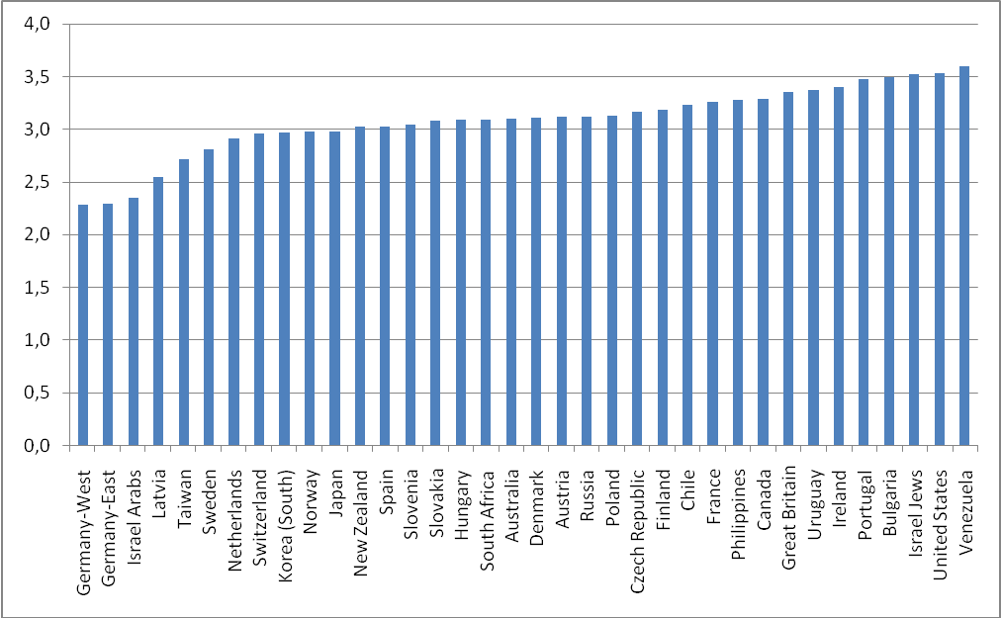

Figure 2.15. Country average scores on the pride in the country’s history

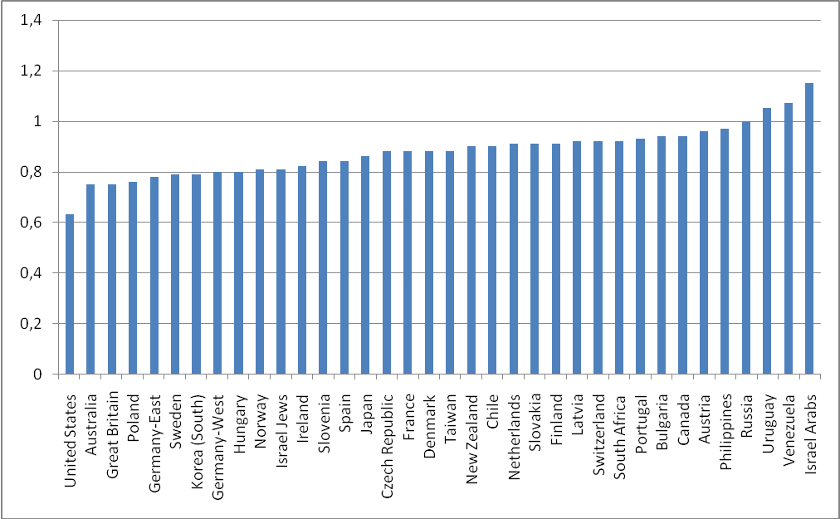
Figure 2.16. Country standard deviations of the pride in the country’s history

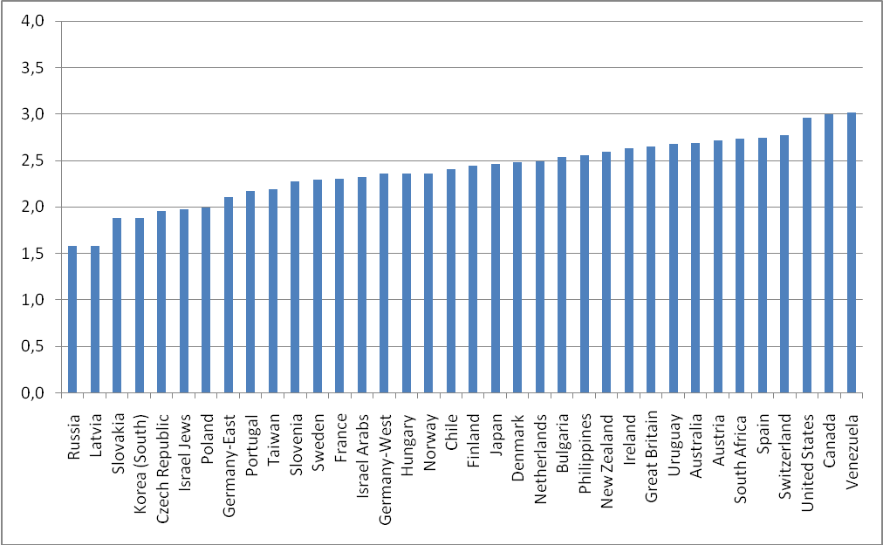

Figure 2.17. Country average scores on the pride in the country’s fair and equal treatment of all groups in society

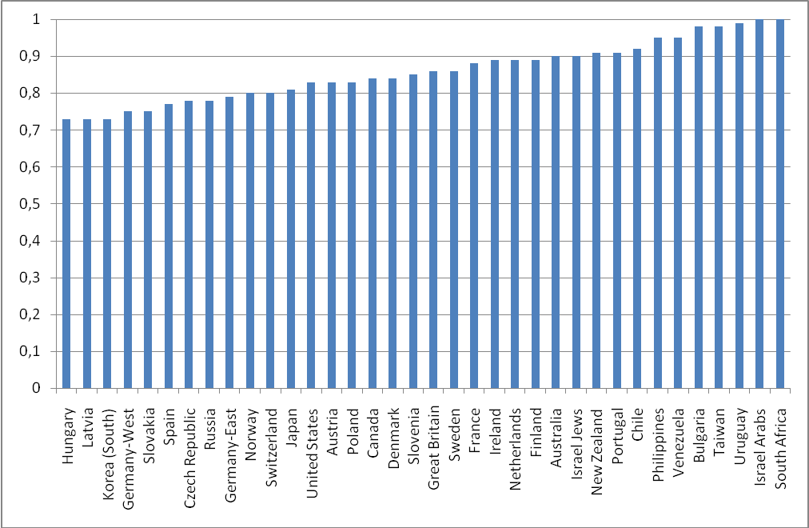
Figure 2.18. Country standard deviations of the pride in the country’s fair and equal treatment of all groups in society

Appendix 3

Validization of Factor Structure of National Pride

Each of the following five tales represents results of the reproduction of the factor analysis on the ten variables related to national pride. The procedure identical to the original factor analysis was conducted separately on five different randomly selected subsamples, each including a different randomly selected 50% of cases from the whole sample.

Facets of national pride | Factor 1 | Factor 2
Q5d How proud: Country’s social security system | 0,65 | -0,42
Q5a How proud: The way democracy works in the country | 0,68 | -0,39
Q5c How proud: Country’s economic achievements | 0,71 | -0,31
Q5b How proud: Country’s political influence in the world | 0,71 | -0,22
Q5j How proud: Country’s fair and equal treatment of all groups in society | 0,65 | -0,19
Q5h How proud: Country’s armed forces | 0,64 | 0,13
Q5e How proud: Country’s scientific and technological achievements | 0,64 | 0,21
Q5i How proud: Country’s history | 0,49 | 0,45
Q5g How proud: Country’s achievements in the arts and literature | 0,56 | 0,56

Facets of national pride | Factor 1 | Factor 2
Q5d How proud: Country’s social security system | 0,66 | -0,42
Q5a How proud: The way democracy works in the country | 0,69 | -0,39
Q5c How proud: Country’s economic achievements | 0,71 | -0,31
Q5b How proud: Country’s political influence in the world | 0,71 | -0,21
Q5j How proud: Country’s fair and equal treatment of all groups in society | 0,66 | -0,21
Q5h How proud: Country’s armed forces | 0,65 | 0,12
Q5e How proud: Country’s scientific and technological achievements | 0,65 | 0,23
Q5i How proud: Country’s history | 0,50 | 0,45
Q5g How proud: Country’s achievements in the arts and literature | 0,57 | 0,56

Facets of national pride | Factor 1 | Factor 2
Q5d How proud: Country’s social security system | 0,65 | -0,43
Q5a How proud: The way democracy works in the country | 0,68 | -0,40
Q5c How proud: Country’s economic achievements | 0,71 | -0,32
Q5b How proud: Country’s political influence in the world | 0,71 | -0,21
Q5j How proud: Country’s fair and equal treatment of all groups in society | 0,65 | -0,20
Q5h How proud: Country’s armed forces | 0,64 | 0,14
Q5e How proud: Country’s scientific and technological achievements | 0,64 | 0,22
Q5i How proud: Country’s history | 0,50 | 0,45
Q5g How proud: Country’s achievements in the arts and literature | 0,56 | 0,56

Facets of national pride | Factor 1 | Factor 2
Q5d How proud: Country’s social security system | 0,64 | -0,43
Q5a How proud: The way democracy works in the country | 0,68 | -0,40
Q5c How proud: Country’s economic achievements | 0,71 | -0,32
Q5b How proud: Country’s political influence in the world | 0,72 | -0,21
Q5j How proud: Country’s fair and equal treatment of all groups in society | 0,65 | -0,20
Q5h How proud: Country’s armed forces | 0,64 | 0,14
Q5e How proud: Country’s scientific and technological achievements | 0,65 | 0,22
Q5i How proud: Country’s history | 0,50 | 0,47
Q5g How proud: Country’s achievements in the arts and literature | 0,56 | 0,56

Facets of national pride | Factor 1 | Factor 2
Q5d How proud: Country’s social security system | 0,65 | -0,43
Q5a How proud: The way democracy works in the country | 0,69 | -0,40
Q5c How proud: Country’s economic achievements | 0,71 | -0,30
Q5b How proud: Country’s political influence in the world | 0,72 | -0,20
Q5j How proud: Country’s fair and equal treatment of all groups in society | 0,66 | -0,19
Q5h How proud: Country’s armed forces | 0,64 | 0,15
Q5e How proud: Country’s scientific and technological achievements | 0,64 | 0,20
Q5i How proud: Country’s history | 0,49 | 0,47
Q5g How proud: Country’s achievements in the arts and literature | 0,55 | 0,57

Appendix 4

OLS Regression Models of the Three Estimates of National Pride

Table 1. OLS Regression Models for the Domain-based Factor of General National Pride
 | OLS with Individual Characteristics Only | OLS with Individual Characteristics and Country Dummies
Individual-level effects
Age (years) | 0.006*** | 0.004***
Gender (0-male, 1-female) | -0.025* | -0.016
Marital status (from 1 – official marriage to 5 – single) | 0.023*** | 0.006
Education (from 0 – no formal education to 5 – university degree completed) | -0.053*** | -0.043***
Employment status (0 – part-time or not employed, 1 – employed full time) | 0.042*** | 0.025*
Church attendance (from 1 – never to 8 – several times a week) | 0.044*** | 0.026***
Subjective social status (from 1 – lowest to 10 – highest) | 0.110*** | 0.055***
Country dummies (reference country Russia)
Australia | - | 1.002***
Germany-West | - | 0.239***
Germany-East | - | 0.131**
Great Britain | - | 0.377***
USA | - | 1.266***
Austria | - | 0.738***
Hungary | - | 0.307***
Ireland | - | 0.946***
Netherlands | - | 0.442***
Norway | - | 0.440***
Sweden | - | 0.265***
Czech Republic | - | -0.014
Poland | - | -0.062
Bulgaria | - | -0.262**
New Zealand | - | 0.771***
Canada | - | 1.006**
Philippines | - | 0.344***
Israel Jews | - | 0.210***
Israel Arabs | - | 0.180**
Japan | - | 0.504***
Spain | - | 0.668***
Latvia | - | -0.255***
Slovakia | - | -0.213***
France | - | 0.557***
Portugal | - | 0.103**
Chile | - | 0.695***
Denmark | - | 0.652***
Switzerland | - | 0.660***
Venezuela | - | 0.803***
Finland | - | 0.575***
South Africa | - | 0.446***
Taiwan | - | -0.151***
South Korea | - | -0.056
Uruguay | - | 0.311***
R2 | 7.3 | 25.4
N | 36309 | 36309
* significant at 0.05; ** significant at 0.01; *** significant at 0.001
AIC – Akaike information criterion, BIC – ‎Bayesian information criterion

Table 2. OLS Regression Models for the Domain-based Factor of the Inverse Relations between the Pride in Elitist and Mass Country Achievements
 | OLS with Individual Characteristics Only | OLS with Individual Characteristics and Country Dummies
Individual-level effects
Age (years) | -0.001*** | -0.000
Gender (0-male, 1-female) | 0.133*** | 0.108***
Marital status (from 1 – official marriage to 5 – single) | -0.009*** | -0.004
Education (from 0 – no formal education to 5 – university degree completed) | -0.006* | -0.004*
Employment status (0 – part-time or not employed, 1 – employed full time) | 0.004 | 0.011
Church attendance (from 1 – never to 8 – several times a week) | 0.013*** | -0.006**
Subjective social status (from 1 – lowest to 10 – highest) | -0.064*** | -0.019***
Country dummies (reference country Russia)
Australia | - | -0.399***
Germany-West | - | -0.899***
Germany-East | - | -0.538***
Great Britain | - | -0.210***
USA | - | -0.332***
Austria | - | -0.586***
Hungary | - | 0.154***
Ireland | - | -0.141***
Netherlands | - | -0.785***
Norway | - | -0.839***
Sweden | - | -0.595***
Czech Republic | - | 0.134***
Poland | - | -0.150***
Bulgaria | - | 0.477***
New Zealand | - | -0.249***
Canada | - | -0.611***
Philippines | - | -0.285***
Israel Jews | - | -0.249***
Israel Arabs | - | -1.144***
Japan | - | -0.234***
Spain | - | -0.656***
Latvia | - | -0.132***
Slovakia | - | 0.161***
France | - | -0.536***
Portugal | - | 0.052**
Chile | - | -0.422***
Denmark | - | -0.962***
Switzerland | - | -0.912***
Venezuela | - | -0.003
Finland | - | -0.880***
South Africa | - | -0.136***
Taiwan | - | -0.820***
South korea | - | -0.359***
Uruguay | - | -0.271***
Adjusted R2 | 3.2 | 22.0
N | 36309 | 36309
* significant at 0.05; ** significant at 0.01; *** significant at 0.001
AIC – Akaike information criterion, BIC – ‎Bayesian information criterion

Table 3. Regression Models for the Direct Single-item Estimate of General National Pride
 | OLS with Individual Characteristics Only | OLS with Individual Characteristics and Country Dummies
Individual-level effects
Age (years) | 0,003*** | 0,003***
Gender (0-male, 1-female) | 0,011 | 0,009
Marital status (from 1 – official marriage to 5 – single) | -0,002 | -0,009***
Education (from 0 – no formal education to 5 – university degree completed) | -0,051*** | -0,054***
Employment status (0 – part-time or not employed, 1 – employed full time) | 0,014 | 0,002
Church attendance (from 1 – never to 8 – several times a week) | 0,051*** | 0,025***
Subjective social status (from 1 – lowest to 10 – highest) | 0,029*** | 0,031***
Country dummies (reference country Russia)
Australia | - | 0,296***
Germany-West | - | -0,705***
Germany-East | - | -0,661***
Great Britain | - | 0.038***
USA | - | 0,414***
Austria | - | 0,010
Hungary | - | 0,026
Ireland | - | 0,282***
Netherlands | - | -0,437***
Norway | - | -0,108***
Sweden | - | -0,1780***
Czech Republic | - | -0,303***
Poland | - | -0,041***
Bulgaria | - | -0,376***
New Zealand | - | 0,222***
Canada | - | 0,325***
Philippines | - | 0,372***
Israel Jews | - | 0,042
Israel Arabs | - | -0,527***
Japan | - | -0,041
Spain | - | -0,046
Latvia | - | -0,201***
Slovakia | - | -0,172***
France | - | -0,174***
Portugal | - | 0,096***
Chile | - | 0,382***
Denmark | - | -0,117***
Switzerland | - | -0,210***
Venezuela | - | 0,563***
Finland | - | -0,026
South Africa | - | 0.292***
Taiwan | - | -0,015
South korea | - | -0,340***
Uruguay | - | 0,347***
Adjusted R2 | 4.8 | 17.7
N | 34657 | 34657
* significant at 0.05; ** significant at 0.01; *** significant at 0.001
AIC – Akaike information criterion, BIC – ‎Bayesian information criterion

