Please ensure you have also uploaded through your JLE account the following supplementary files:
- a brief autobiographical note on a separate sheet
Your Name (First M. Last). Omit titles add degrees
Institution Name (University, Town, State)
Your ORCID
Provide full correspondence details here including e-mail
Correspondence concerning this article should be addressed to Ben Aroud, University of Bialystok, ul. M. Skłodowskiej-Curie 14, Białystok, Poland, 19-276. E-mail: baroud@gmail.com)

Contact details and academic affiliations for all co-authors should also be submitted in this file. Also, please, identify who is to be the corresponding author.

Funding information should be included.

Declaration of competing interests also should be presented.

Author contributions (follow CREDIT author statement | https://jle.hse.ru/crt) should be presented in following manner:
Marina Ivanova: conceptualization, methodology, software.
Nataliya Back.: data curation, writing - original draft preparation.
John Dress: visualization, investigation.
Mary Ibson: supervision.
Andy Crowl: software, validation.
Mina Exx: writing - reviewing and editing.

- Cover letter (check its template in Information for authors)

As part of the submission process you are required to warrant that you are submitting your original work, that you have the rights in the work, that you are submitting the work for first publication in the Journal and that it is not being considered for publication elsewhere and has not already been published elsewhere, and that you have obtained and can supply all necessary permissions for the reproduction of any copyright works not owned by you. Also the novelty of your research should be explained.

Article type: Original Research Article

Full Title of Your Paper

Author information has been removed for blind review / Author information should be presented for open review

Abstract
Background. It should be clear what gap in knowledge the author is filling. The relevance of the research is determined by the gap being filled in the existing knowledge on the topic.
Purpose. The purpose of the research should be fully stated. It is not enough to indicate that the goal is to conduct research; it is important to show WHY the author is implementing it.
Method. Key aspects of the materials and methods used by the author should be mentioned. It should be clear to the reader HOW the author conducted the research in order to achieve the set goal. If the author does not mention participants, materials, methods, and procedures (even briefly), it will be quite difficult for the reader to understand the essence of the results described in the abstract.
Results. All obtained results should be listed in a generalized form without including excessive details. In the abstract, it is important to provide the reader with an overview of the data obtained to pique their interest and encourage them to read the Results section in the main body of the article.
Conclusion. Conclusions are intended to demonstrate the significance of the obtained results, to show what gap in knowledge has been filled by the results and how they can be used in real practice. In the abstract, it is necessary to simply point out all these aspects, while their detailed content is available in the corresponding section. It is not permissible to use clichés that do not allow understanding the significance of the obtained results—for example, "The obtained results allowed us to highlight a number of recommendations for use in the practice of university activities." Everything must be described in real SPECIFIC terms.
Keywords: insert 5 to 10 keywords here, lowercase, separated by commas, no period after the keyword sequence. Note: The keywords are typed in regular font, not in italics

Introduction
The introduction of a scientific paper acquaints the reader with the context surrounding the issue being addressed. It should convey the issue's relevance and its contemporary significance within the broad spectrum of global research efforts.
An introduction goes beyond merely juggling words to suit the facts; it is also shaped by the expected responses of peer colleagues. In essence, an introduction is akin to a movie trailer. A compelling introduction ensures to engage the reader from the start.
It should (1) establish a territory (research area + statement of a general research question), (2) establish a niche (moving from general research question to the gap in knowledge to be filled = specific research question), (3) to demonstrate how to occupy a niche (how to find the solution).
While establishing niche, it is necessary:
(1) to state the general topic and provide some significant and attention-grabbing background about it. It is essential to include references to the sources from which the author derived statistics, data, and examples to highlight the social significance of the issues described.
(2) to provide a brief and relevant review of the literature related to the topic. However, the goal here is not so much to describe previous research on the topic as it is to systematize the existing body of knowledge on the subject. In other words, it is important to create a roadmap: what directions in the study of the declared problem exist. What are the strengths and weaknesses in each of the directions. That is, it is necessary to summarize the research into thematic subgroups and present each as a story describing the content of the trend. Citation of sources is mandatory.
If the topic has not been sufficiently studied to identify trends in its coverage, it is necessary to comment on the issues that most attract the attention of researchers and discuss the aspects of its coverage. The logic of the description in both cases should be such as to gradually lead the reader to the author's motivation for conducting the research.
(3) to add a paragraph on the scope of the topic including the need for the presented study (general research question).
The second stage is connected with the nice establishing and requires:
- Stating the importance of the problem.
- Outlining the current situation regarding the problem citing both global and national data.
- Evaluating the current situation (advantages/ disadvantages) based on previous research. Ideally, to present a constructive challenge to previous research on the topic, based on accurate and justified criticism. What was overlooked, what was overestimated, why the previously used research methodology was not sufficiently relevant, and so on.
- Identifying the gaps in knowledge on topic.
Occupying the niche is the third portion of the introduction defining the rationale of the research and stating the research question. If this is missing the reviewers and readers will not understand the logic for the research. An example: Till date, no study has been done to see the effectiveness of … in the closure ….. So, the present study is aimed at comparing the effectiveness of … versus … to find the ….
The next steps will be:
(1) Emphasizing the importance of the proposed research and how the gaps will be addressed.
(2) Stating the research aim and questions. Research questions help authors to be more focused. In the results section, they assist in organizing the presentation of results more effectively.
(3) Stating the hypotheses briefly. Commenting on the hypothesis will also enable the author to effectively construct the Discussion section.
(4) A brief description of the research methodology is designed to help readers assess the logic and effectiveness of the author's actions.
(5) The same purpose is served by a brief description of the obtained results (in one sentence) and their significance for the advancement of science and society.
The section should not exceed 2-3 pages of text on average. An excess of text may prevent the reader from clearly seeing the essence of the research.

Literature Review (if needed)
The literature review should be included as a separate section of the paper. It should not encompass an analysis of previous research on the topic merely to inform readers. It is required to justify contentious aspects, comment on concepts, lead to a consensus of definitions, and highlight different approaches to the topic. In other words, it should lead the reader to an understanding of the essence and significance of the current research's results.
The text of the literature review should be divided into thematic subsections to make it easier for the reader to follow the author's logic.
The aims and research questions of the research should be presented in the introduction, while in the literature review they can be commented on specifically from the perspective of prior knowledge in the subject area.
In APA style used in JLE any source you use in your paper must have an in-text citation. In APA these citations include the author’s last name and the year of the publication in parentheses (Aroud, 2017). If the source you are using does not identify an author, use a shortened version of the source title rather than the author name (E-Portfolios for Education, 2006). For more details see https://apastyle.apa.org/style-grammar-guidelines/references/examples.
APA 7.0 supports five levels of headings.

Heading Level 1

Heading Level 2
Text begins indented as a new paragraph.
Heading Level 3
Text begins indented as a new paragraph.
Heading Level 4. Text begins on the same line and continues as a regular paragraph.
Heading Level 5. Text begins on the same line and continues as a regular paragraph.
The heading styles are set in this document to correspond with those heading levels 1 through 5. The next heading is a Heading 1. It will be followed by a Heading 2.

Method
The section is intended to help other researchers reproduce the current study by seeing it through the eyes of the author. Hence, all necessary details should be presented in sufficient volume.
Text should have subsections with headings. For example, a Method section might include Participants, Materials, Instruments, Method, Procedure and Analysis subsections.

Results
The goal of the Results section is to present the main findings of the research without deducing their meaning. Here, the grouped data and the results of the statistical analyses carried out are included. Figures, tables and graphs are also placed here, as well as a summary or description of the data. Information such as the subjects’ average scores or ratings and how the scores varied among the different groups should also be included in this section.
The Results section should always be presented in a systematic way following the sequence of the Methods section on which the results are based (in other words - includes subsections that describe the answer to a particular experimental procedure that was elaborated in the Methods / refers to the experimental protocols described in the Methods section). It’s often helpful to use tables describing results, especially when the author has a lot of data to report (such as means and standard deviations) or is describing correlations. Sometimes it is helpful to remind the reader of the hypothesis before presenting each result. It is also a good idea to tell the reader what type of data analysis was done (e.g., correlation, ANOVA) before it is presented.

Outcome 1
Text. Text. Text.

Outcome 2
Text. Text. Text.

Discussion
The objective here is to provide an interpretation of your results and support for all of author’s conclusions, using evidence from the presented research and generally accepted knowledge, if appropriate. Suggest explanations for deviations from previously published results, etc. Emphasize any theoretical or practical consequences of the results.
Open the Discussion section with a clear statement of the support or nonsupport for your original hypotheses, distinguished by primary and secondary hypotheses. If hypotheses were not supported, offer post hoc explanations.
Similarities and differences between your results and the work of others should be used to contextualize, confirm, and clarify your conclusions. Results should also be commented in a theoretically meaningful way (How do the findings fit in with previous theory and literature? Are the results consistent or inconsistent with what has been found in the past? If they are inconsistent, how can it be explained?).
Do not simply reformulate and repeat points already made; each new statement should contribute to your interpretation and to the reader’s understanding of the problem.
Your interpretation of the results should take into account (a) sources of potential bias and other threats to internal validity, (b) the imprecision of measures, (c) the overall number of tests or overlap among tests, (d) the effect sizes observed, and (e) other limitations or weaknesses of the study. If an intervention is involved, discuss whether it was successful and the mechanism by which it was intended to work (causal pathways) and/or alternative mechanisms. Also, discuss barriers to implementing the intervention or manipulation as well as the fidelity with which the intervention or manipulation was implemented in the study, that is, any differences between the manipulation as planned and as implemented.
Acknowledge the limitations of your research and address alternative explanations of the results. Discuss the generalizability, or external validity, of the findings.
This critical analysis should take into account differences between the target population and the accessed sample. For interventions, discuss characteristics that make them more or less applicable to circumstances not included in the study, how and what outcomes were measured (relative to other measures that might have been used), the length of time to measurement (between the end of the intervention and the measurement of outcomes), incentives, compliance rates, and specific settings involved in the study as well as other contextual issues.
End the Discussion section with a reasoned and justifiable commentary on the importance of findings.
Include limitations of the study. Describe the ways in which the internal or external validity of the study may have been compromised. Was the sample biased? Were the measures problematic? Think about what you would do different next time if you conducted a similar study. Future research ideas are often discussed when limitations are discussed.

Conclusion
Conclusion should be the best part of a research paper. It should serve as a synopsis of the whole work, engaging scientists with a conversational tone that steers clear of the weeds of technicality. It is an opportunity to discuss the importance of the findings. What are the implications of this research? Should there be a need for further study, now is the moment to suggest potential future directions.
Start with a concise articulation of your objectives and a recap of your research's key points. Avoid delving into the minutiae or statistical details; those belong in the main text. Present your conclusions by delving into the relevance of your results. How does your work contribute to the field? What additional research is warranted?
Now's your chance to provoke thought. Summarize your work succinctly and meaningfully, not just by rehashing content, but by adding value. Elaborate on your results in a manner that prompts the reader to ponder their broader significance. Aim to illustrate the larger context, helping the reader grasp the real-world relevance of your study.
The conclusion isn't for repetitive or trivial details; it's where you should paint the broader strokes and suggest what comes next. It's a chance to transcend the minutiae and emphasize the potent endgame of your research.
A typical structure of conclusion section starts by introducing the topic, followed by stating the objective of your study succinctly, possibly in just a sentence or two. Next, distill your findings using accessible terminology, highlighting your research's significance.
After outlining the key points, underscore the distinctive importance of what you've discovered. If you're advancing an argument, it's critical to illuminate the implications of these findings and their bearing on real-world challenges. Communicate your results in a manner that underscores their wider connections within your discipline, advocating for the tangible applications your work may have.
Conclude your paper with a call to action, if fitting, to inspire subsequent studies. This final note should not only summarize but also encourage further exploration, setting a trajectory for future scholarly endeavors.

Acknowledgments
Acknowledgements, funding information and declaration of competing interests have been removed for blind review.
Conflict of interests
The authors declare that they have no conflict of interest.

References
The relevant number of the in-text cited works is at least 30. And at least half of them should go Scopus / WoS indexed and newly published. The use of good references throughout the paper gives the work credibility.
If your reference has a DOI, include that DOI (It is MANDATORY). Please, use the following doi format http://dx.doi.org/10.1037/rmh0000008
Herbst, D. M., Griffith, N. R., & Slama, K. M. (2014). Rodeo cowboys: Conforming to masculine norms and help-seeking behaviors for depression. Journal of Rural Mental Health, 38, 20–35. http://dx.doi.org/10.1037/rmh0000008

Reference management software. Some reference template available in many of the most popular reference management software products. We recommend Mendeley. Users of Mendeley Desktop can easily install the reference style for this journal by clicking the following link: http://open.mendeley.com/use-citation-style/international-journal-of-educational-research. When preparing your manuscript, you will then be able to select this style using the Mendeley plug-ins for Microsoft Word or LibreOffice.

Aroud, B. H., Breck, P. T., & Falkone, R. M. (2016). Title of journal article. Journal of Research in Personality, 13, 254-276. http://dx.doi.org/10.1016/0032-026X.56.6.895
B’Markone, S. O. (2017). Modern education: Questions and answers. Journal of Language and Education, 4(3), 55-79.
Cranch, B. E., Aroud, B. P., & Falkone, R. (1999). Technology in modern life. Pearson.
Aroud, B. E. (2009). Words. In The new encyclopedia Britannica (vol. 38, pp. 745-758). Penguin.
Aroud, B. E. (2017). Words in articles. In A. Fallone (Ed.), Research projects (pp. 745-758). Penguin.
Cranch, B. R., & Falkone, A. C. (2011). Science and education. In P. Z. Albert, R. Brings & J. H. Cramm (Eds.), Research papers evaluation (pp. 123-256). Simon & Schuster.
Bennahmiasm, J.-L., & Roche, A. (1992). Des verts de toutes les couleurs: Histoire et sociologie du mouvement ecolo [Greens of all colours: History and sociology of the ecology movement]. Albin Michel.
Piaget, J. (1969). The psychology of the child (H. Weaver, Trans.). Basic Books.
Abramson, M. (2004, March 1). This is how to cite an online news article. The Washington Post. http://www.washingtonpost.com/dir/subdir/2014/05/11/a-d9-11e3_story.html
Considine, M. (1986). Australian insurance politics in the 1970s: Two case studies (Unpublished doctoral dissertation). University of Melbourne, Melbourne, Australia.

For all other cases (e.g., references to websites, reports, sources in languages other than English, unpublished manuscripts, etc., please refer to the APA manuscript style manual, 7th edition or Reference list section in Information for authors (https://jle.hse.ru/ref). You may find the APA style blog useful for additional information (http://blog.apastyle.org). All references need to be in APA manuscript style before the manuscript can go into copyediting and will be returned to the author if the formatting is not complete.

Common peculiarities are indicated below
References
Aroud, B. H., Breck, P. T., & Falkone, R. M. (2016). Title of the article. Journal of Research in Personality, 13, 254-276. doi:10.1016/0032-026X.56.6.895

B’Markone, S. O. (2017). Modern education: Questions and answers. Journal of Language and Education, 4(3), 55-79.

Cranch, B. E., Aroud, B. P., & Falkone, R. (1999). Technology in modern life (7th ed.). Pearson.

Aroud, B. E. (2009). Words. In The new encyclopedia Britannica (vol. 38, pp. 745-758). Penguin. http://dx.doi.org/10.1016/0032-026X.56.6.895

Aroud, B. E. (2017). Words in articles. In A. Fallone (Ed.), Research projects (2nd ed., pp. 745-758). Penguin.
Cranch, B. R., & Falkone, A. C. (2011). Science and education. In P. Z. Albert, R. Brings & J. H. Cramm (Eds.), Research papers evaluation (pp. 123-256). Simon & Schuster.
Editor, J. J., Editor, A. A., & Editor, P. P. (Eds.). (2012). Book title: And subtitle. Routledge.
Bennahmiasm, J.-L., & Roche, A. (1992). Des verts de toutes les couleurs: Histoire et sociologie du mouvement ecolo [Greens of all colours: History and sociology of the ecology movement]. Albin Michel.
Piaget, J. (1969). The psychology of the child (H. Weaver, Trans.). Basic Books.
Abramson, M. (2004, March 1). This is how to cite an online news article. The Washington Post. http://www.washingtonpost.com/dir/subdir/2014/05/11/a-d9-11e3_story.html
Considine, M. (1986). Australian insurance politics in the 1970s: Two case studies [Unpublished doctoral dissertation]. University of Melbourne.

Appendix
If your paper only has one appendix, label it "Appendix" (without quotes.) If there is more than one appendix, label them "Appendix A," "Appendix B," etc. (without quotes) in the order that each item appears in the paper. In the main text, you should refer to the Appendices by their labels.
The actual format of the appendix will vary depending on the content; therefore, there is no single format. In general, the content of an appendix should conform to the appropriate APA style rules for formatting text
Each appendix must have a capitalised title.
In the text, refer to appendices by their labels:
“… produced the same results for both studies (see Appendices A and B for complete proofs).”
Begin each appendix on a separate page.
Place the label and title of each appendix at the top of the page, centered, using normal capitalization. Label first, title second.
E.g.

APPENDIX A

EXERCISES USED IN THE COURSE

Footnotes
1Add footnotes, if any. To format a footnote reference, select the number and then, on the Home tab, in the Styles gallery, click Footnote Reference. The body of a footnote, such as this example, uses the Normal text style.
Only scientific materials should be included into Reference list. For other sources use Footnotes.
Use footnotes to cite sources which are not scientific or for explanatory (content) notes or copyright permission. Content footnotes contain information that supplements the text but would be distracting or inappropriate to include in the body of the paper. In other words, such footnotes provide important information that is a tangent to what you are discussing in your paper.
The footnote should only express one idea. If it is longer than a few sentences, then you should consider putting this information in an appendix. Most authors do not use footnotes because they tend to be distracting to the readers. If the information is important, authors find a way to incorporate it into the text itself or put it in an appendix.

Diagrams, Formulas, Special Characters
Submit diagrams and complex formulas as images (instead of importing them from other software or by using the Word formula editor). Do not include special characters as miniature images. Instead, use designated Word fonts (e.g., Symbol) or the Word Symbol Function under “Insert > Symbol”.
Text within diagrams must be in Times New Roman font (exceptions: symbols not available with Times New Roman), between 8 and 12 point.

Tables
APA Style tables have the following basic components:
- number: The table number (e.g., Table 1) appears above the table title and body in bold font. Number tables in the order in which they are mentioned in your paper.
- title: The table title appears one double-spaced line below the table number. Give each table a brief but descriptive title, and capitalize the table title in italic title case.
- headings: Tables may include a variety of headings depending on the nature and arrangement of the data. All tables should include column headings, including a stub heading (heading for the leftmost, or stub, column). The heading “Variable” is often used for the stub column if no other heading is suitable. Some tables also include column spanners, decked heads, and table spanners; these are described in the Publication Manual. Center column headings and capitalize them in sentence case.
- body: The table body includes all the rows and columns of a table (including the headings row). A cell is the point of intersection between a row and a column.
  - The table body may be single-spaced, one-and-a-half-spaced, or double-spaced.
  - Left-align the information in the leftmost column or stub column of the table body (but center the heading).
  - In general, center information in all other cells of the table. However, left-align the information if doing so would improve readability, particularly when cells contain lots of text.
- note: Three types of notes (general, specific, and probability) appear below the table as needed to describe contents of the table that cannot be understood from the table title or body alone (e.g., definitions of abbreviations, copyright attribution, explanations of asterisks used to indicate p values). Include table notes only as needed. All of them must be placed below the table in that order.
General notes explain, qualify or provide information about the table as a whole. Put explanations of abbreviations, symbols, etc. here.
Specific notes explain, qualify or provide information about a particular column, row, or individual entry. To indicate specific notes, use superscript lowercase letters (e.g. ª, ^{b}, ^{c}), and order the superscripts from left to right, top to bottom. Each table’s first footnote must be the superscript ª.
ª n = 654. ^{b} One participant in this group was marked as a potential leader.
Probability notes provide the reader with the results of the tests for statistical significance. Asterisks indicate the values for which the null hypothesis is rejected, with the probability (p value) specified in the probability note. Such notes are required only when relevant to the data in the table. Consistently use the same number of asterisks for a given alpha level throughout your paper.
*p < .05. **p < .01. ***p < .001

If you are adapting or reprinting a table or figure that was originally published by someone else, you will need to provide a copyright statement beneath the table or figure as well as include a corresponding reference entry.
Adapted from “Skills and Competencies in Higher Education and Beyond,” by L. Raitskaya, & E. Tikhonova, 2019, Journal of Language and Education, 5(4), p. 7 (https://doi.org/10.17323/jle.2019.10186). Copyright 2019 by National Research university Higher School of Economics.

Table 1
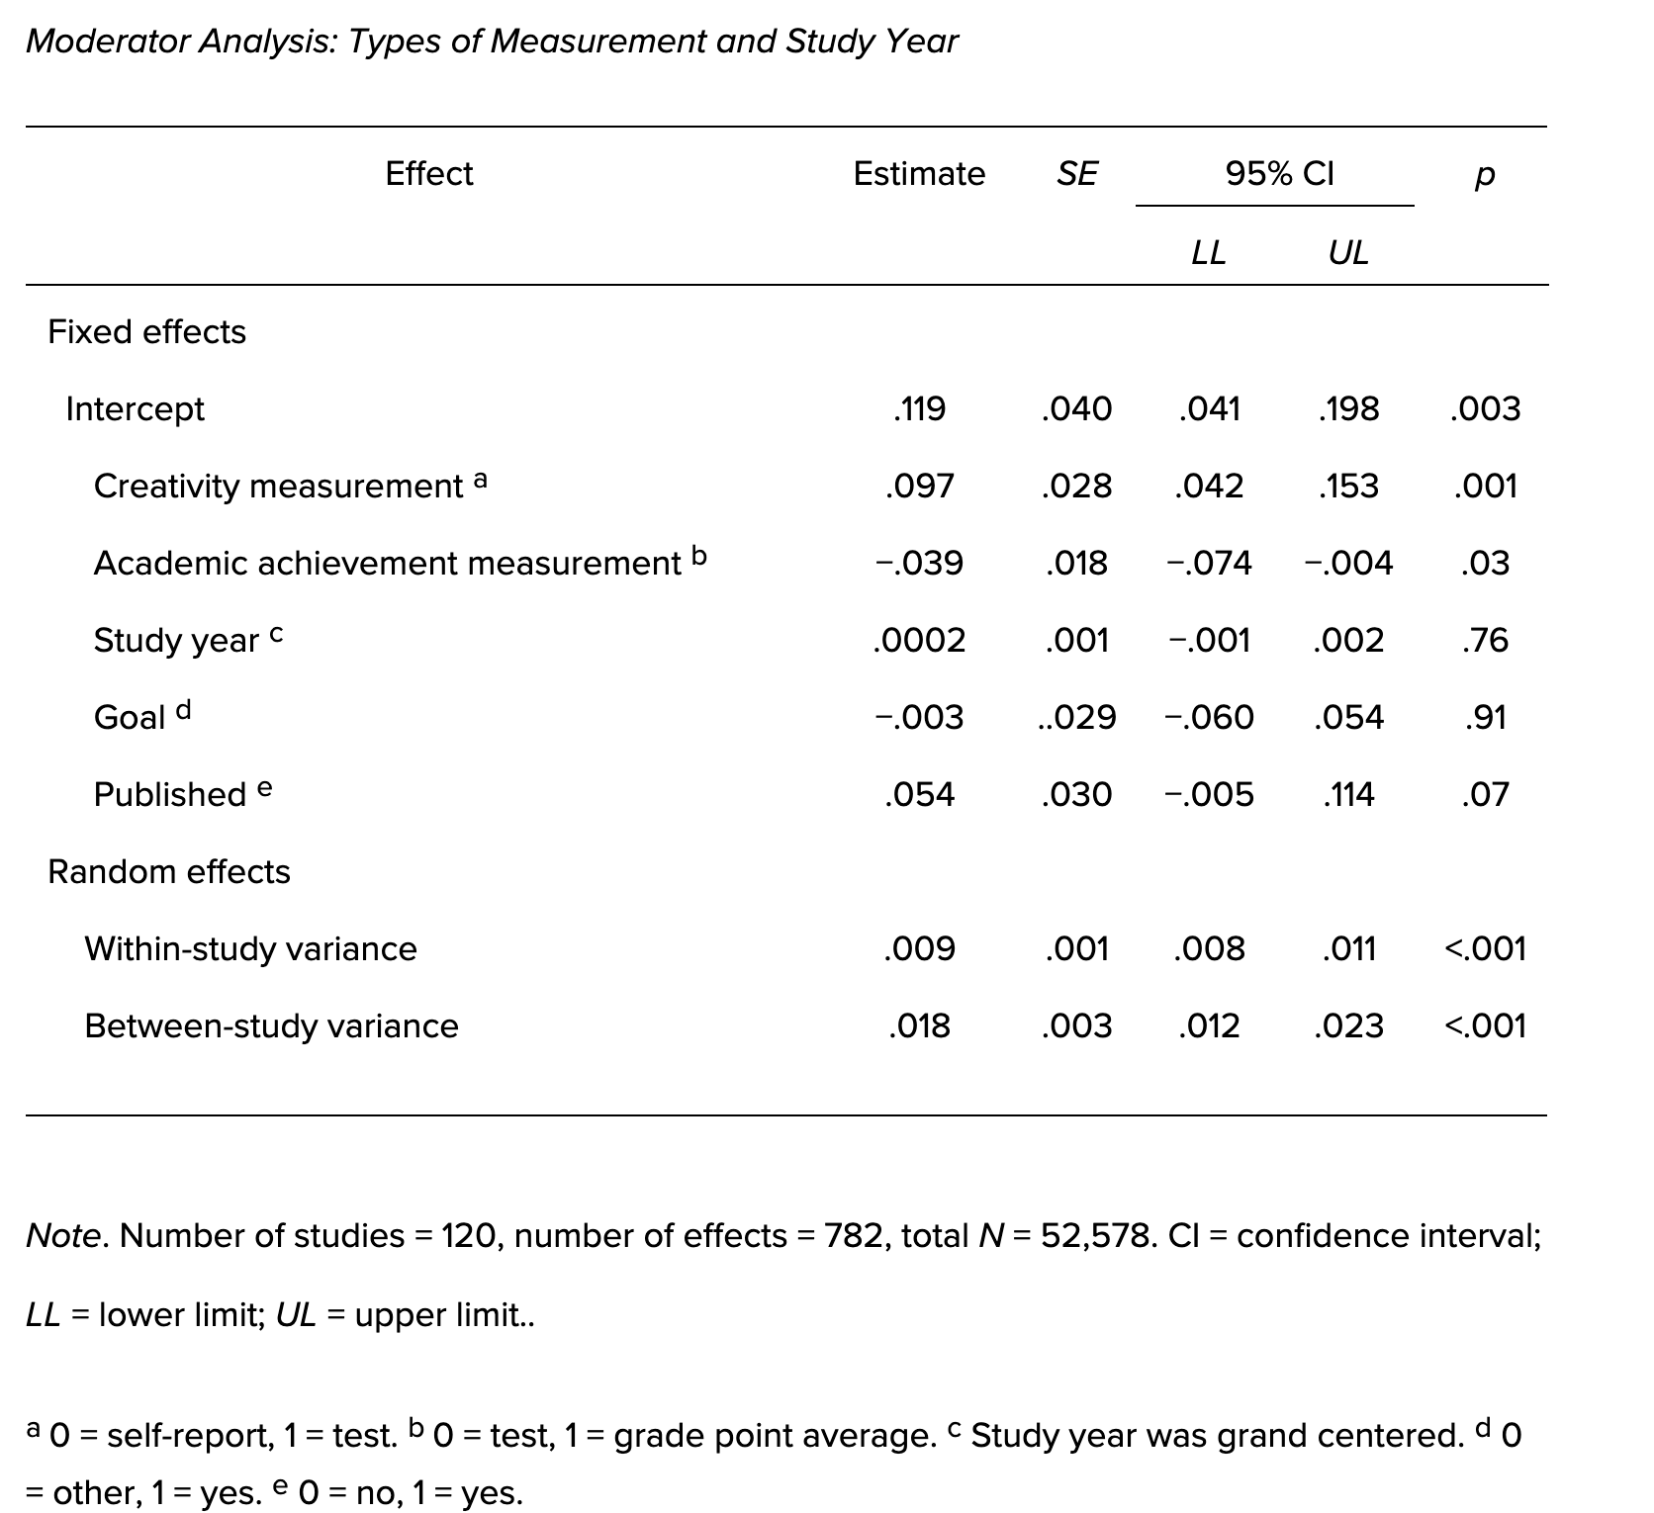

Each table should be displayed with a brief explanatory title
You must include a caption beneath the table
All explanatory text appears in a table note that follows the table, such as this one.

Please submit tables as editable text and not as images. Tables should be placed next to the relevant text in the article. Number tables consecutively in accordance with their appearance in the text and place any table notes below the table body. Be sparing in the use of tables and ensure that the data presented in them do not duplicate results described elsewhere in the article.
Tables should only include borders and lines that are needed for clarity (i.e., between elements of a decked head, above column spanners, separating total rows, etc.). Do not use vertical borders, and do not use borders around each cell. Spacing and strict alignment is typically enough to clarify relationships between elements.

Figures
APA Style figures have the following basic components:
- number: The figure number (e.g., Figure 1) appears above the figure title and image in bold font. Number figures in the order in which they are mentioned in your paper.
- title: The figure title appears one double-spaced line below the figure number. Give each figure a brief but descriptive title, and capitalize the figure title in italic title case.
- image: The image portion of the figure is the graph, chart, photograph, drawing, or other illustration itself. If text appears in the image of the figure (e.g., axis labels), use a sans serif font between 8 and 14 points.
- legend: A figure legend, or key, if present, should be positioned within the borders of the figure and explains any symbols used in the figure image. Capitalize words in the figure legend in title case.
- note: Three types of notes (general, specific, and probability) can appear below the figure to describe contents of the figure that cannot be understood from the figure title, image, and/or legend alone (e.g., definitions of abbreviations, copyright attribution, explanations of asterisks use to indicate p values). Include figure notes only as needed.

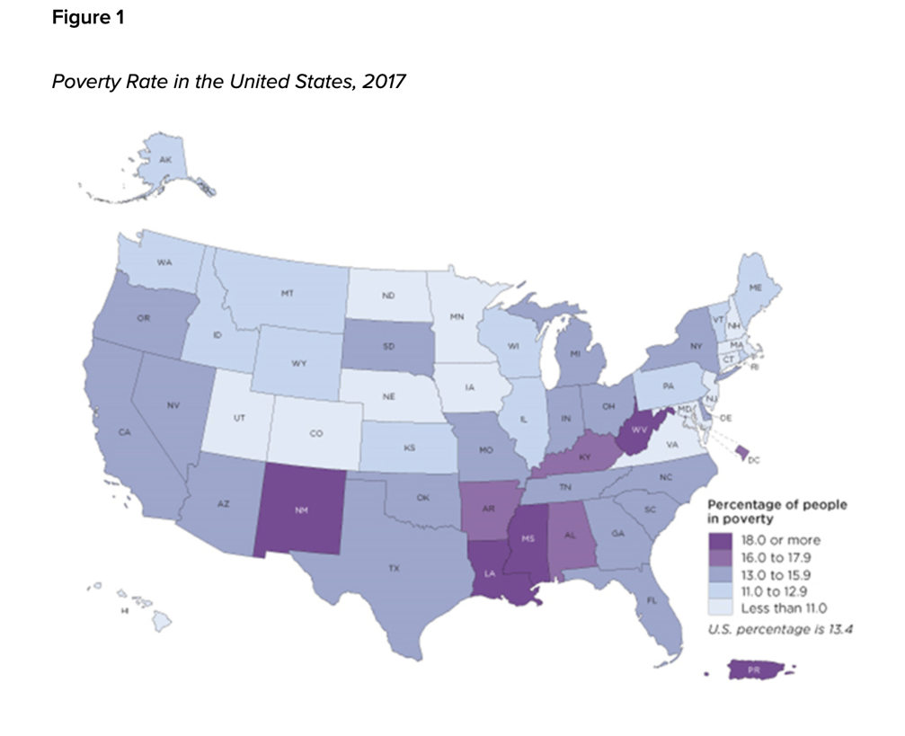
Note. The map does not include data for Puerto Rico. Adapted from 2017 Poverty Rate in the United States, by U.S. Census Bureau, 2017 (https://www.census.gov/library/visualizations/2018/comm/acs-poverty-map.html). In the public domain.

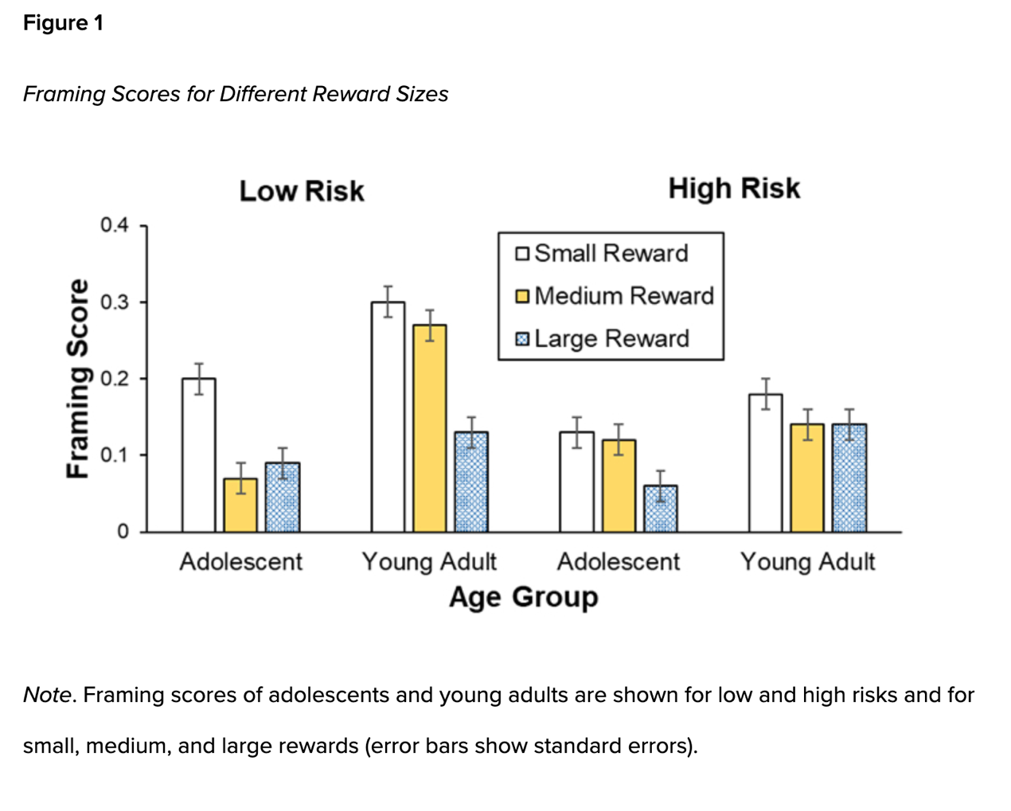 Principles of Figure Creation
The most important principle to follow when creating a figure is to present information in a way that is easy for readers to understand. Provide sufficient information in the figure itself so that readers do not need to read the text to understand it.
When creating a figure, ensure you meet the following standards:
- images are clear
- lines are smooth and sharp
- font is legible and simple
- units of measurement are provided
- axes are clearly labeled
- elements within the figure are clearly labeled or explained
Use graphics software to create figures in APA Style papers. For example, use the built-in graphics features of your word-processing program (e.g., Microsoft Word or Excel) or dedicated programs such as Photoshop or Inkscape.
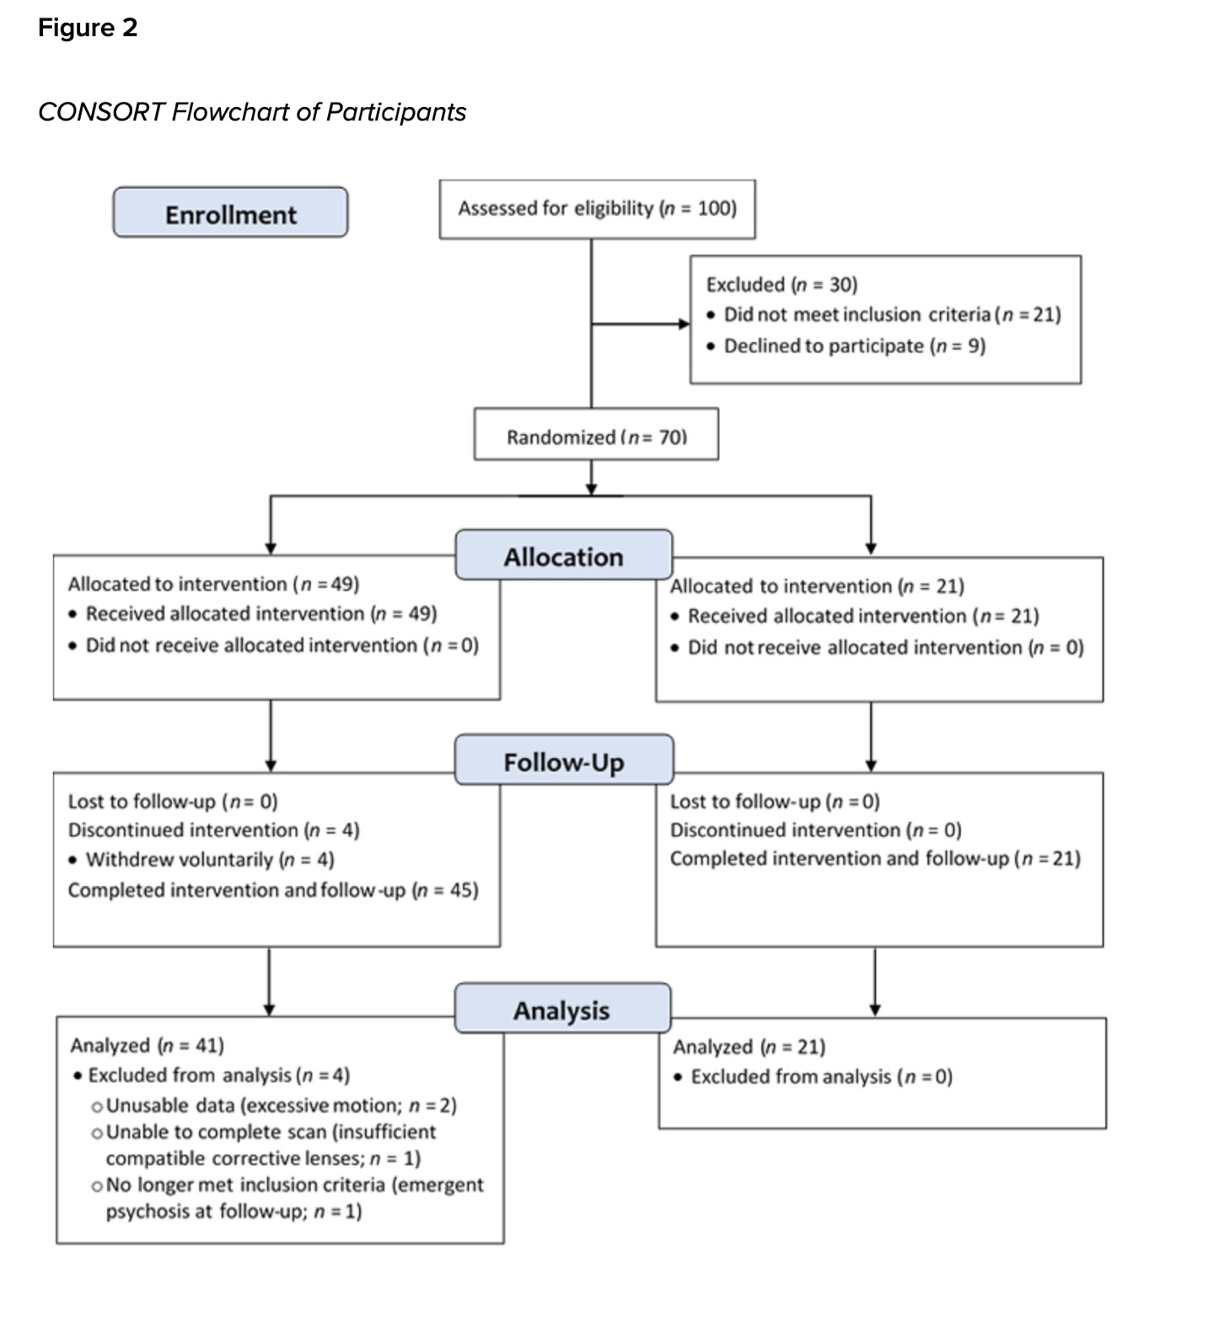
For more information about all elements of APA formatting, please consult the APA Style Manual, 7th Edition.

Text. Text. Text.

